Digital Twins: A Survey on Enabling Technologies, Challenges, Trends and Future Prospects
Stefan Mihai, Mahnoor Yaqoob, Dang V. Hung, William Davis, Praveer Towakel, Mohsin Raza, Mehmet Karamanoglu, Member, IEEE, Balbir Barn, Member, IEEE, Dattaprasad Shetve,
Raja V. Prasad, Member, IEEE, Hrishikesh Venkataraman, Member, IEEE, Ramona Trestian, and Huan X. Nguyen, Senior Member, IEEE

Abstract—Digital Twin (DT) is an emerging technology sur-rounded by many promises, and potentials to reshape the future of industries and society overall. A DT is a system-of-systems which goes far beyond the traditional computer-based simula-tions and analysis. It is a replication of all the elements, processes, dynamics, and firmware of a physical system into a digital counterpart. The two systems (physical and digital) exist side by side, sharing all the inputs and operations using real-time data communications and information transfer. With the incor-poration of Internet of Things (IoT), Artificial Intelligence (AI), 3D models, next generation mobile communications (5G/6G), Augmented Reality (AR), Virtual Reality (VR), distributed com-puting, Transfer Learning (TL), and electronic sensors, the digital/virtual counterpart of the real-world system is able to pro-vide seamless monitoring, analysis, evaluation and predictions. The DT offers a platform for the testing and analysing of complex systems, which would be impossible in traditional sim-ulations and modular evaluations. However, the development of this technology faces many challenges including the complex-ities in effective communication and data accumulation, data unavailability to train Machine Learning (ML) models, lack of processing power to support high fidelity twins, the high need for interdisciplinary collaboration, and the absence of standardized development methodologies and validation measures. Being in the early stages of development, DTs lack sufficient documentation. In this context, this survey paper aims to cover the important aspects in realization of the technology. The key enabling tech-nologies, challenges and prospects of DTs are highlighted. The

Manuscript received 30 September 2021; revised 7 April 2022 and
12 August 2022; accepted 20 September 2022. Date of publication
22 September 2022; date of current version 22 November 2022. This work was supported in part by the U.K.–India Education and Research Initiative (UKIERI) under Grant DST UKIERI-2018-19-011; in part by the British Council’s Institutional Links through the Newton Programme Vietnam Partnership under Grant 429715093; and in part by the British Council Indonesia’s Going Global Partnerships Programme (2022–2024). The fund in the programmes delivered by the British Council was provided by the U.K. Department of Business, Energy and Industrial Strategy. The work of Huan
X. Nguyen was supported by the VinGroup Innovation Fund (VinIF) under Grant VINIF.2021.DA00192. (Corresponding author: Ramona Trestian.)
Stefan Mihai, Mahnoor Yaqoob, William Davis, Praveer Towakel, Mehmet Karamanoglu, Balbir Barn, Ramona Trestian, and Huan X. Nguyen are with the London Digital Twin Research Centre, Middlesex University, NW4 4BT London, U.K. (e-mail: sm3488@live.mdx.ac.uk; my365@live.mdx. ac.uk; wd085@live.mdx.ac.uk; pt445@live.mdx.ac.uk; m.karamanoglu@mdx. ac.uk; b.barn@mdx.ac.uk; r.trestian@mdx.ac.uk; h.nguyen@mdx.ac.uk).
Dang V. Hung is with the Department of Civil Engineering, National University of Civil Engineering, Hanoi 0000, Vietnam (e-mail: hungdv@nuce. edu.vn).
Mohsin Raza is with the Department of Computer Science, Edge Hill University, L39 4QP Ormskirk, U.K. (e-mail: mohsin.raza@edgehill.ac.uk).
Dattaprasad Shetve, Raja V. Prasad, and Hrishikesh Venkataraman are with the Indian Institute of Information Technology, Sri City 517646, India (e-mail: dattaprasad.s@iiits.in; yrv.prasad@iiits.in; hvraman@iiits.in).
Digital Object Identifier 10.1109/COMST.2022.3208773
paper provides a deep insight into the technology, lists design goals and objectives, highlights design challenges and limitations across industries, discusses research and commercial develop-ments, provides its applications and use cases, offers case studies in industry, infrastructure and healthcare, lists main service providers and stakeholders, and covers developments to date, as well as viable research dimensions for future developments in DTs.
Index Terms—Digital twin, digital transformation, smart man-ufacturing, industry 4.0, structural health monitoring, 5G.

- Introduction
T
HE FOURTH Industrial Revolution is in full bloom, and the current global Covid-19 pandemic has even fur-
ther accelerated the digital transformation by several years. The travel restrictions, lockdowns, and pending economic decline have forced industry executives to adapt their business prospects and shift their focus from saving costs to increasing investments in digital development [1]. Additionally, the global viral outbreak has imposed a dynamic uncertainty upon the economic world, and companies found themselves compelled to cope with and quickly adapt to ever-changing conditions and restrictions in order to survive or even rise above the cir-cumstances [2]. However, even before the sanitary crisis, the efforts towards digitalization were considerable. Cisco pub-lished their annual Internet report in the first fiscal quarter of 2020, and they predicted a significant growth in world-wide Internet users (66% of the population in 2023, compared to 51% in 2018), networked devices (3.6 devices per person in 2023, as opposed to 2.4 in 2018), and reduced commu-nication latency that encourages the development of real-time interactive applications [3]. This forecast expansion of Internet coverage, speed, and connections is giving way to an increased rate of information dissemination, availability, and accessi-bility, as well as growing opportunities of development and innovation.
The goals of Industry 4.0 (I4.0) align perfectly with this fast-paced and continuously-evolving digital transformation. I4.0 aims to automate all the traditional, bare-metal indus-trial practices, and it hopes to do so by bringing as much of the of the equipment from the physical space into the vir-tual domain. And this is where Digital Twins come into play. DTs emerged as an experimental technology set to enable replication of elements, functions, operations and dynamics of physical systems into digital world, with better control at

1553-877X ⃝c
2022 IEEE. Personal use is permitted, but republication/redistribution requires IEEE permission. See https://www.ieee.org/publications/rights/index.html for more information.

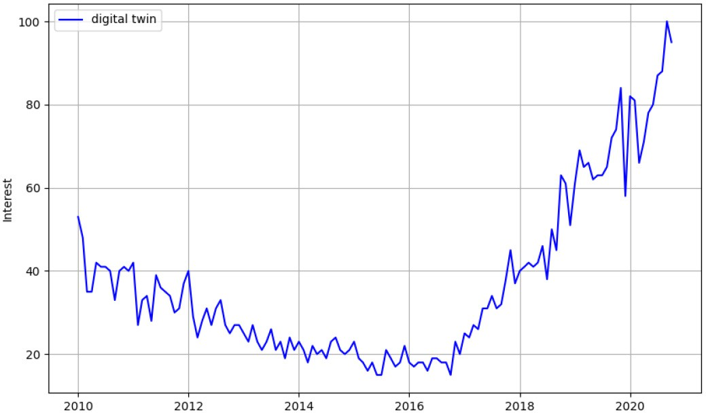

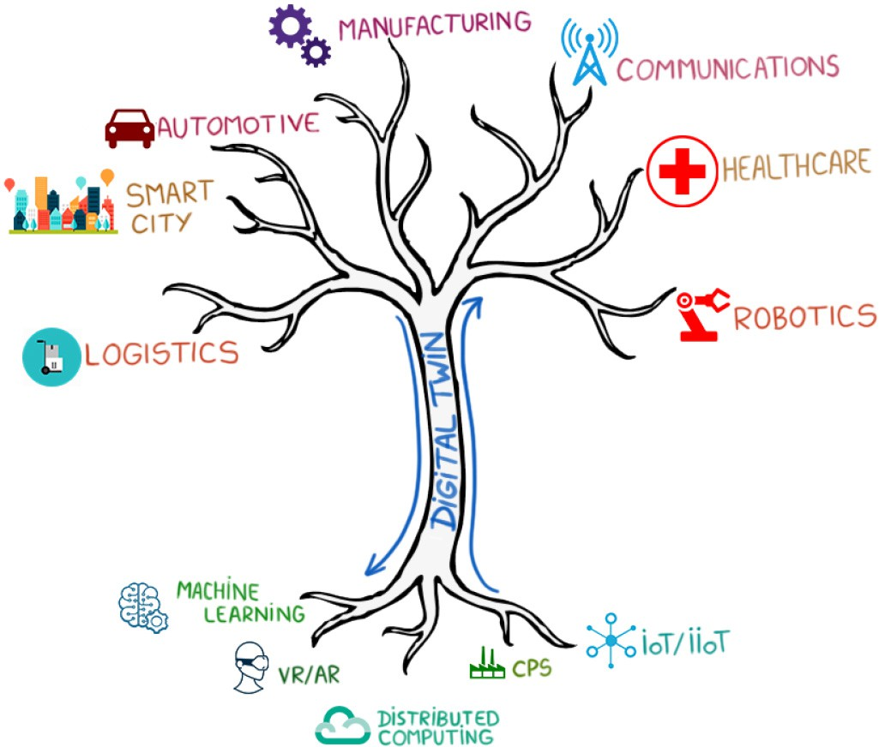
Fig. 1. The Digital Twin’s central role in the Industry 4.0 era.

testing, analysis, prediction and hazard prevention for sen-sitive processes. However, the supporting technologies, until recently, were not advanced enough to develop DTs for com-plex systems or systems-of-systems. The recent developments in Machine Learning, Artificial Intelligence, data integration Virtual/Augmented Reality, sensing, security, cloud storage, Transfer Learning, data visualization and ultra-reliable low latency communications (uRLLC) have enabled the implemen-tation of the DT and its extended applications across several industries. A technology thought to be capable of dealing with isolated operations and processes, the DT can now offer poten-tial applications eventually replicating the processes, elements, dynamics, firmware, connections and operations of physical systems in digital world. Figure 1 illustrates the DT as a supplier of various services across industries in I4.0.
The formation of a mirror image of a physical system in the digital world offers unlimited possibilities. Interlinking the physical and digital systems through seamless data trans-fer allows the virtual system to exist simultaneously with the physical system. Real-time data communications between the physical and digital systems enable a synchronized and coher-ent operation of the real and virtual counterparts. Once in the digital domain, optimized learning, information transfer, analysis, visualization, optimization and planning can easily be incorporated to see the potential improvements with sug-gested changes. Thus, the DT can be used effectively to assess, observe and validate the physical system, suggest changes and visualize the potential improvements. Previously deemed as an impossibility, DTs have arisen as one of the key technologies with potential to reshape the future.
This survey paper aims to shine light on the recent advance-ments in the DT paradigm by reviewing the relevant literature published over the last few years, in order to establish a common understanding of this technology, explore its market potential and trends, enumerate its most prominent enabling technologies, offer an in-depth look at several applications,
Fig. 2. Interest trend in Digital Twin as seen through Google searches.

frameworks, and case-studies that have been thoroughly doc-umented, and finally discuss and share the learned lessons and remaining challenges of this technological pacesetter.

- Background and Motivation
The Digital Twin gained traction in 2002, after Michael Grieves held a presentation at the University of Michigan, which was entitled “Conceptual Ideal for Product Lifecycle Management”. The original slide containing the proposed con-cept was reproduced by Grieves and Vickers in [4] and it can be noted that the early architecture of what would later become the DT consisted of three main components:
  - the real space,
  - the virtual space,
  - the link serving as a communication medium between the two spaces.
The implications of this idea were revolutionary for the manufacturing industry, and other economic domains would later pick up on this as well. The most important advantage of the original DT was the conjoined lifetimes of the real and virtual entities, starting from the creation of the pair, and end-ing in their disposal. This feature suggests that the virtual asset would, at all times, mirror the most recent representative char-acteristics of the physical system, allowing remote monitoring throughout the whole lifetime of the physical object. As such, while it was initially intended as a tool for monitoring the life-cycle of a manufactured product, academia and the industry soon realised that the DT concept can be fruitfully applied to other economic domains as well.
As a result of this realisation, research output has surged and interest and representation of the digital twin has grown. Figure 2 shows the global trend of interest into the term “dig-ital twin” as expressed via the normalized number of Google searches across the last 11 years, and it can be noted that the last few years have drawn increased attention to the concept that Michael Grieves introduced back in 2002. The “interest” shown on the Y-axis takes values between 0 and 100, where a value of 100 denotes the highest popularity the search term has seen during one month of the given time window, and a value of 50 represents half of that maximum popularity.
While the Google Search trend is a representation of the DT’s increasing general popularity across the years, it is

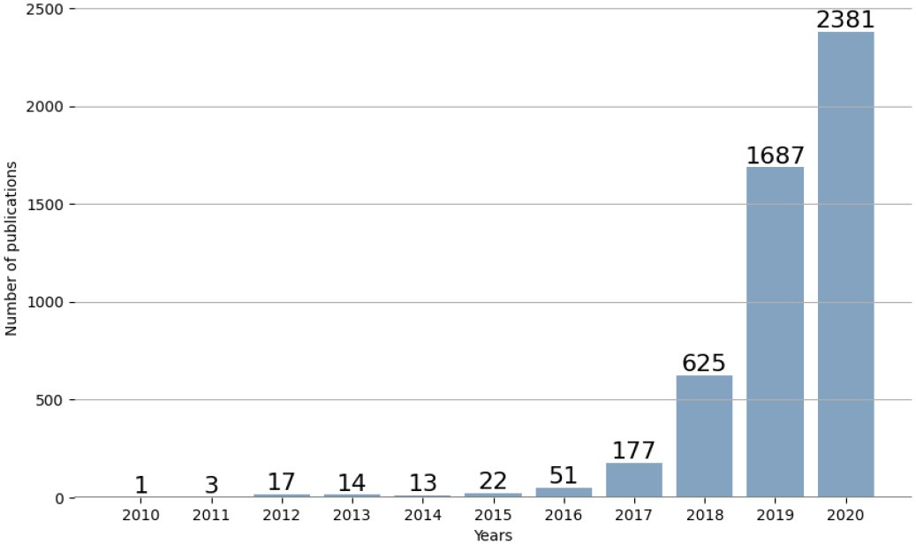

Fig. 3. Number of articles in the Scopus database whose abstracts contain the phrase “digital twin” across the years.

important to assess and understand how this growing attention has been reflected in the research output throughout the same time period. In this regard, we analysed the number of pub-lications within the Scopus document database that included the phrase “digital twin”, for each year in the last decade. Figure 3 shows the results of this analysis and, indeed, it can be noted that increasing attention has been allocated to the research and development of this revolutionary paradigm as well. The bar plot shown in Figure 3 is the result of leverag-ing the Scopus Search API to search for articles that contain the specific phrase “digital twin” in their abstracts. While not all of the found articles might have been devoted entirely to the DT concept, it is still noteworthy that more and more aca-demics have taken some level of interest in the technology over the years. It is also important to mention that the search was accomplished via the “pybliometrics” package of Python, developed by Rose and Kitchin [5].

- Related Surveys
There is currently a considerable number of publications across literature that are dedicated to advance the concept of a DT. In fact, there are so many articles that academics have also put out a number of survey papers that were designed to review the state-of-the-art in DT development, illuminate fellow inno-vators on possible research gaps, questions and directions, as well as guide the industry towards possible DT use cases that might generate significant business value in their specific domain. This work aims to complement the other existing sur-vey efforts and facilitate a complete understanding of the DT, with its definitions, enabling technologies, applications, and detailed use-cases and case-studies.
As such, Table I displays a comparison between a collection of other survey articles covering comprehensive DT-related lit-erature, and the survey paper at hand. Table I puts in contrast the contributions of this paper with other surveys’, in order to highlight the novelty brought by the work at hand. The findings of this study are analysed below in more detail.
Barricelli et al. [6] propose a study on the DT’s defini-tions, characteristics, applications, and design implications. The paper provides full coverage of the DT’s evolution, from Michael Grieves’ concept to the state-of-the-art at the time of
its publishing. The authors set out to answer three research questions, regarding the various definitions that the DT has accumulated across the years, the paradigm’s main charac-teristics (feature selection and extraction, that facilitate the DT-characteristic Big Data analysis, pattern recognition and ML, predictive and prescriptive analytics, etc.), as well as the main domains where the DT had been applied at the time of writing. In particular, the authors detail several DT implementations across three different application domains: manufacturing, healthcare, and aviation. The paper ends with the design implications and challenges that developers should take into account when considering such a system. In contrast, this work’s goal is to expand Barricelli et al.’s contributions by additionally discussing the market potential of the DT, going into further details on the technologies that enable a DT’s characteristics, and also providing a closer look at possible use-cases in different industry domains.
Minerva et al. [7] proposed a comprehensive survey on the architectural models of a DT, and they also discussed the technical features of this concept (or, in other words, the technical “must-haves”) that consolidate the DT definition. The paper surveys different DT characteristics that were high-lighted in literature pertaining to various technological and industrial domains, like manufacturing, AR/VR, multiagent systems, virtualisation, and especially IoT. Additionally, the authors applied proactive thinking and evidentiated some other important characteristics of the DT that are often overlooked in other research works, like data ownership, contextualisation, augmentation, servitisation, etc. The paper covers the value of the DT concept, including its market potential, before div-ing into various detailed use-cases, like the digital city and the digital patient. The survey ends with a consolidated DT architectural model and illuminates the upcoming challenges. While the article proposed by Minerva et al. contours the defi-nitions, enabling technologies and applications of a DT, it does not go into details about which technologies can be integrated into the DT in order to build those applications. The survey at hand will attempt to fill that gap.
Löcklin et al. [8] published a survey paper that tackles the DT’s use for verification and validation (V&V) purposes. The authors mention that there are multiple DT definitions in the literature, before settling on one definition that makes a dis-tinction between the Digital Twin, which is mainly referred to as a tool for monitoring, verification and validation, and the Intelligent Digital Twin, that can provide meaningful feed-back to its corresponding asset based on the acquired data. Furthermore, the survey is conducted around three research questions that tackle how the DT can enable verification and validation, the industrial domains where the DT is used for V&V, and a classification of modalities in which the DT is leveraged in the reviewed papers. As the title of the survey sug-gests, it is dedicated to studying the application of verification and validation within multiple industrial domains.
Biesinger et al. [9] conducted a survey on the necessity of a DT in the automotive industry’s integration planning processes. Unlike the previously presented articles, which focused on reviewing scholarly works, this study has been con-ducted by interviewing 22 production planners from various

TABLE I
Comparison Between This Survey Paper’s Contributions and Other Related Works in the Literature

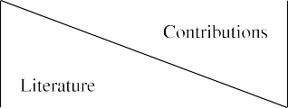
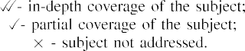

automotive manufacturing companies. The scope of the paper, which is a case-study by itself, covers the demand of an eas-ily accessible and configurable DT for the specific use-case of integration planning. As such, it is a great indicator of the market potential that the DT has in this industrial sector, but it does not delve into the possible solutions or enabling tech-nologies that could help implement a DT that is compliant with the definitions that the authors provide in their work.
He et al. [10] proposed a survey focused mostly on the monitoring and surveillance capabilities of the DT, and their provided definition (“a dynamic digital replica of physical assets, processes, and systems, which comprehensively mon-itors their whole lifecycle”) reflects this aspect of the study. Although the authors do not emphasise the full extent of the DT definition, they do present the technologies that enable the DT to become an avant-garde methodology for the spe-cific application of surveillance. The survey concludes with an industrial use-case of the DT, dubbed Pavatar, and presents the technical advantages and challenges of implementing this project for an ultra-high voltage converter station.
Pires et al. [11] present a compact review of the DT’s def-initions, enabling technologies, and applications, ending the paper with the exemplification of a case-study of the DT and the challenges the concept will face before the industry inte-grates it into its businesses. The authors also provide a look at on-going research efforts towards building a DT for a UR3
collaborative robot. The manuscript at hand aims to comple-ment this work with a wider array of references and case studies.
Rasheed et al. [12] created a comprehensive DT sur-vey that analyses the paradigm from the perspectives of its value (expressed via services and software platforms), applica-tions, enabling technologies, and challenges. The paper brings together works from various domains where the DT has been tried and tested, as well as potential socio-economic impacts that such a technology can have (i.e., loss of jobs, training new workforce in DT specifics).
In [13], Tao et al. introduce a thorough analysis of 50 papers and 8 patents related to the DT. The authors cover the concept of DT via a study of four perspectives: interaction and collab-oration between its constituents, data fusion, services, and DT modeling and simulation. Then, the authors describe the DT’s applicability in three main areas in its most prominent industry, the manufacturing sector: DTs for product design, for produc-tion, and for prognostics and health management. As such, the paper draws its lessons from articles that are mostly focused on the state of the art of DTs in the manufacturing industry.
In [14], Huang et al. put together a detailed survey on the AI-driven DTs in the context of smart manufacturing and advanced robotics. The authors take into consideration the advantages of using a DT as a driver for sustainabil-ity goals in the manufacturing and robotics, by facilitating

production planning and control, quality control, dynamics control, predictive maintenance, and many other services. Additionally, the authors focus on describing how AI tech-niques specifically enable DTs across these two domains.
Finally, Fuller et al. in [15] propose an extensive survey on DT, with a focus on its integration with IoT and data analytics technologies. The paper also points out that there is a need for a stable DT definition that consolidates all of the aspects that make up a true DT. Afterwards, the survey goes on to discuss the DT, its enabling technologies, and applications in three main use cases: smart city, healthcare, and manufacturing. The manuscript at hand aims to complement the aforementioned articles in providing a complete view of the DT.
- Survey Contributions
To complement the previous works, this work provides a comprehensive survey on the DT concept, the enabling tech-nologies involved, the applications and use cases for deploying DTs across various industries. The main contributions of this survey paper are summarized as follows:
  - Overview of the DT definitions from the literature;
  - Comprehensive discussions on the market potential of DT;
  - The enabling technologies for DT are surveyed, such as: ML, cloud, fog and edge computing, IoT/IIoT, Cyber-Physical Systems, VR/AR, and modeling technologies;
  - Existing solutions of DT frameworks are reviewed across three use cases examples, namely: smart factory, infras-tructure, and future directions for 6th Generation Mobile Networks (6G). Then, we take a closer look at two DT services, irrespective of use case: anomaly detection and predictive maintenance;
  - Three real use cases of DTs as applied to tea indus-try in India, Festo Cyber-Physical Factory in the United Kingdom, and structural health monitoring for Vietnam bridges are discussed in details;
  - Lessons learned, remaining open challenges and future directions of DTs are identified.

- Survey Structure
This survey paper is organized as follows: Section II pro-vides a review and comparison of the existing DT definitions across the recent literature covered in this paper, as well as our own comprehensive DT interpretation, Section III eval-uates the DT’s potential for market adoption and current trends in DT development, Section IV delves into some of the most prominent DT enabling technologies and reviews how other researchers used them to build working DTs, Section V explores various DT frameworks and applications proposed in the literature, Section VI takes a closer look at three DT case studies, Section VII draws the lessons we learned through-out this survey, establishes the current challenges that the DT faces, and contours possible future directions, and finally Section VIII summarizes the conclusions of this paper.
An overview of the organization and structure of this paper is illustrated in Figure 4. Table II provides a list of abbreviations used in this article.
- Definitions of the Digital Twin
The Digital Twin is not a new paradigm. The premises that initiated its advancements have been introduced more than 50 years ago, amongst NASA’s many efforts of bringing man in space. Indeed, the idea of virtually simulating real-life sce-narios that would normally require extensive resources could not have had a more appropriate origin than NASA’s early space programme, where high-fidelity (relative to the tech-nology standards at the time) simulators were used to train astronauts for their upcoming remote journeys in the outer space. But, surely, there is more to DTs than just simula-tion, so the true precursor of this paradigm actually came to light during NASA’s Apollo 13 [16] mission, when an unex-pected explosion caused a manned spacecraft to deviate from its intended trajectory, endangering the astronauts on-board. In response, the ground-based Mission Control was then tasked to urgently simulate, in almost real-time, the erratic behaviour of the spacecraft, and make optimal decisions to ensure its safe return on Earth, in ever-critical conditions. The engi-neers used the available spacecraft simulators, animated them with real data coming from the space-bound physical ship and its pilots, analysed possible scenarios, then communicated optimal instructions to the stranded pilots to maneuver their ship back home safely. The mission was a success.
Michael Grieves, in 2002, proposed a similar idea as a means to drive forward the Product Lifecycle Management paradigm (PLM), although, back then, he had not dubbed it as “digital twin”, but as “Mirrored Spaces Model”. This pre-cursor of the DT consisted of the same three main pillars that lie at the base of this technology today: real space, virtual space, and the communication thread between them.
In the case of the Apollo incident, the real space was repre-sented by the physical spacecraft stranded in space, the virtual space consisted of the ground-based simulators, and the link between the two was characterised by the continuous com-munication between the Mission Control, the spacecraft, the engineers, and the pilots. It was indeed the DT that saved the day back in 1970.
The actual definition of the DT has always been at least ambiguous, and the ever-growing number of publications in the last few years has only added to the diversity of DT meanings. It is generally observed, however, that the DT implementation attempts so far seem to have been accom-plished with the support of a number of common enabling technologies, such as: ML [17], TL [18], distributed comput-ing (i.e., cloud, fog, and edge computing) [19], the (Industrial) Internet of Things (I/IoT) [20], CPS [21], and VR/AR [22].
Consequently, to get a good grasp on the general under-standing of the DT we analysed the recent literature on the DT definitions provided. The results indicate that the exist-ing DT definitions seem to center around five approaches as summarised in Table III.
Each of the five definitions capture the essence of the DT, but there is not complete overlapping between them:
- The first definition is a very popular one, and arguably the oldest one, however it is very generic and it does not offer insight into the constituent parts of the DT.

TABLE II
List of Acronyms

 | 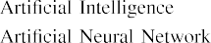  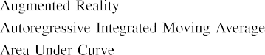  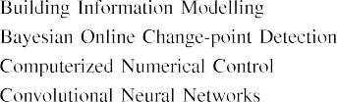  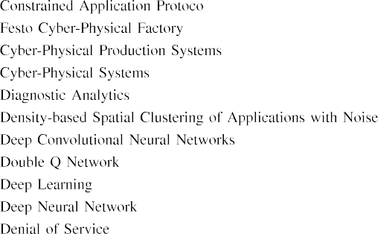  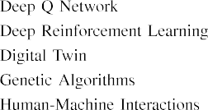  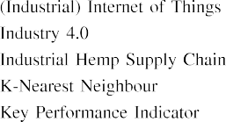 |  | 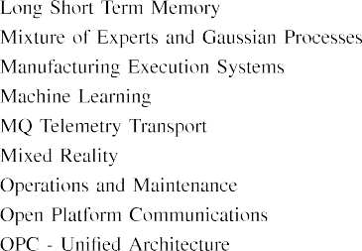  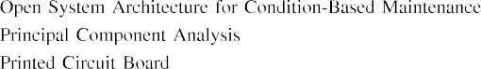  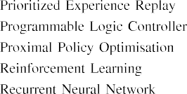  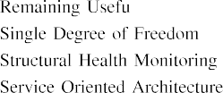  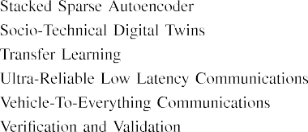

- The second definition is more comprehensive, as it demystifies the DT and provides a bit of understand-ing regarding two of its components (the physical and digital objects). However, it claims that the DT is just an intelligent digital model of a physical asset, with lit-tle to no emphasis on the interaction between the two, its requirements, and limitations. Some works [23], [24], however, do make observations about the twinning rate (i.e., the rate of synchronization between the two objects), and mention that it is a requirement that depends on the DT’s use case.
- The third definition completely ignores the bi-directional communication requirement of a DT, essentially confus-ing the DT with a digital shadow, which would more accurately fit that description.
- The fourth definition focuses entirely on the components of the DT, but it does not hint towards the capabilities of a DT, making the definition too generic.
- The fifth definition shifts its attention to the services pro-vided by the DT, but not on its structure and technologies that enable said services.
To put the five definitions into a better perspective, we will work through a hypothetical example. Consider the DT of
an autonomous car, where the virtual representation of the car is able to continuously communicate with the physical asset and become aware at all times of its state and envi-ronment in order to make appropriate control decisions. The use-case of autonomous driving imposes some strict require-ments on the DT, the most obvious of which are: ultra-low latency communication between the real and virtual twins, large data storage capacity, high processing power to reduce data-to-insight delays, and high-fidelity virtual rendering of the car and its environment.
Now, seeing this example through the lenses of the five def-initions, we would find that some of the above scenario’s very important aspects are omitted. The first and third definitions claim that the DT only mirrors the life of its twin, so they do not envision the other half of the feedback loop between the two entities, where the DT itself can control the car based on its real-time data. The second definition comes close to describing our DT, except that it makes no mention of the DT’s requirements that might differ from use-case to use-case: a DT of an autonomous car will need a higher rate of synchroniza-tion than the DT of an industrial water boiler, for instance. The fourth definition makes no mention of the DT’s use-case at all, even though it is a deciding factor in the choice of enabling

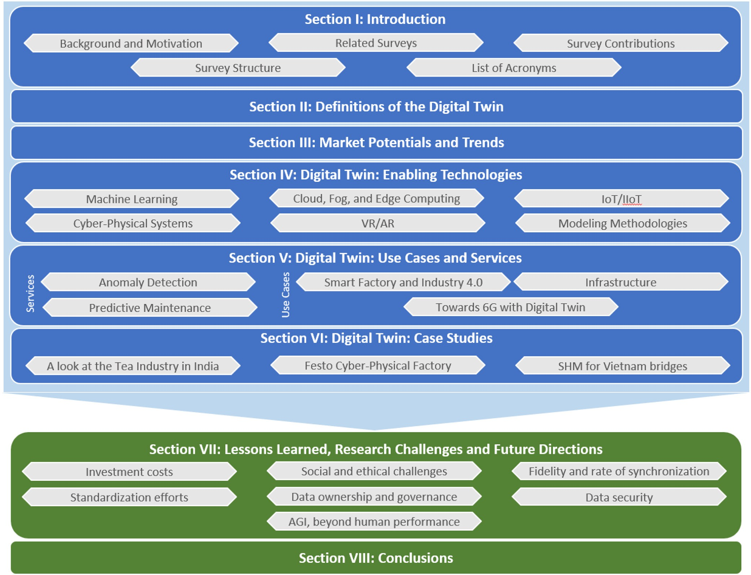

Fig. 4. An overview of the survey paper’s contents.

TABLE III
The Various Definitions of Digital Twins Found in the Literature

technologies and other requirements (a DT for lifetime moni-toring of a car would not need a bi-directional communication medium, unlike a DT for autonomous driving). Lastly, the fifth
definition focuses entirely on the use-case and the services the DT can provide, but the use-case’s requirements and the DT components are only implied via the definitions

of the services themselves, and not explicitly stated as DT characteristics.
It is thus clear that there is a need for a comprehensive definition of the DT. The definition needs to be specific enough that it identifies the components of a DT, how they interact, and what services it should provide, but also generic enough that it can describe DTs across multiple industrial domains and use cases.
As such, in this work, and many hereafter, we will refer to the Digital Twin as a self-adapting, self-regulating, self-monitoring, and self-diagnosing system-of-systems with the following properties: (1) it is characterized by a symbiotic relationship between a physical entity and its virtual represen-tation, (2) its fidelity, rate of synchronization, and choice of enabling technologies are tailored to its envisioned use cases, and (3) it supports services that add operational and business value to the physical entity.
We believe that this alternative provides a better understand-ing of the DT concept, as it gives a precise indication of what the DT is (i.e., a system-of-systems), what its components are (i.e., physical and digital entities), how they interact (symbiotic relationship, i.e., a mutually beneficial two-way interaction), how their interaction is leveraged (i.e., to offer services that bring operational and business value), how accurate and syn-chronized the virtual asset should be, and what technologies should be used to build it (i.e., use case-dependent). Looking back on the DT example for autonomous driving, it is now clear to see which are the DT’s components (the car and its environment are the physical asset, while their virtual model is the digital asset), that they interact through a bi-directional communication medium (one for collecting data from the real space, and another for delivering insights and commands from the virtual twin), that the DT is supposed to, in our case, assist the car in driving autonomously, and that this use-case implies some specific restrictions (low-latency, high security, etc.).
The fundamental characteristics of a DT, which are the motors that actually bring operational and business value to the physical entity, lie centrally in the DT philosophy. The “self-X” constructs distinguish a true DT from digital models and shadows, and emphasize the usefulness of a DT in I4.0. These traits are explained below:
- Self-adapting - a DT automatically reacts to changes in its real twin’s environment and configuration, but it should do so in a way that continually ensures operational excellence (i.e., as measured via use case-appropriate performance measures).
- Self-regulating - the changes a DT undergoes while adapt-ing to its real twin’s environment should not exceed the physical twin’s own limitations for the sake of maximising its performance measures (e.g., productivity, throughput, etc.).
- Self-monitoring - the DT is always aware of its real twin’s environment and configuration, by means of monitoring the parameters that are relevant to its use cases.
- Self-diagnosing - the DT should be able to assess its own health and know, based on its current and historical con-ditions, when and why it is no longer able to maintain optimal operations.
As such, a DT’s services should enable it to be self-adapting, self-regulating, self-monitoring, and self-diagnosing, or, in fewer words, self-evolving.

- Market Potentials and Trends
Academic research on the topic of DT has positioned it thus far as a central player in the race to I4.0. The widely-praised potential of the paradigm presents attractive opportunities and challenges that, once overcome, promise to bring benefits that far outweigh the costs. However, the issue of costs is more prominent in the industry than it is in the academia. While the DT is a versatile technology that can be successfully applied to various domains businesses still remain reluctant to implement the DT. That is because the Return On Investment (ROI) on a DT is difficult to quantify, since it is not a product that directly brings revenue, but rather a technology that aims to reduce and optimize costs. Nevertheless, this section will detail how the leaders in the DT market have leveraged its aptitudes, and whether their results predict a good omen for the future of the DT.
IBM [60], one of the top DT solutions providers, valued the DT market at USD 3.1 billion in 2020 [61], and pre-dicted that the technology would see significant adoption and economic growth in the following years. Although they do admit that the creation of a DT is not always a sound finan-cial investment, IBM’s case studies show encouraging returns and cost optimisations for DT implementations in manufac-turing and smart buildings. For example, ASTRI [62] used DTs to validate software packages before their deployment on the physical twin, reducing 30% of development costs and expediting deployment by 40%. University of California San Francisco [63] implemented DTs for a branch of the Mission Bay Hospital which helped engineers to reduce the diagnosis and repair process of the building’s pipes from 2-3 days to just a few hours.
Another big player on the DT market is Ansys [64], who praise the DT as the bridge between equipment development and equipment operations, allowing manufacturers to monitor the behaviour of their product throughout its whole lifetime. Mecuris [65] have used Ansys products to develop a DT for tailor-made orthoses and prostheses development to reduce product testing costs. Similarly, Jet Towers [66] implemented DTs of modular wireless towers to reduce installation and design time by 80%.
General Electric [67] lead the DT market in the power systems industry, where their solution claims to reduce start-up time by 50% and maintenance costs by 10%, deliver up to $5 million additional MWhr, and save costs on outages of up to $150 million per year. In the telecommunications industry, Spirent [68] are taking the stage as the leading DT solutions provider for 5G networks. To optimise network design, testing, and deployment, Spirent propose leveraging the DT for use cases such as: cellular Vehicle-to-Everything (V2X) virtual drive testing, private 5G networks for smart fac-tories, and testing and design for Communications Service Providers. Another Spirent report [69] praises the DT for its Predictive Maintenance (PdM) aptitudes in I4.0’s smart

factories, claiming to reduce machine breakdown by up to 70% and save up to 25% of maintenance costs [70].
A Markets and Markets report [71] highlights attractive growth opportunities in the DT market and stresses on the increasing need for PdM and business optimisation. The report also states that the market in North America recorded as high as $1.32 billion, the largest share of the overall DT market in 2019, and it is projected to reach $16.94 billion by 2026. The paper forecasts that the global DT economy is expected to grow from $3.2 billion in 2020 to $48.27 billion by 2026 with a Compound Annual Growth Rate of 58%. Another report by the Institution of Engineering and Technology [72] echos the idea that the DT market is on the rise, although it also men-tions that industry-agnostic adoption at the time of publication amounted to only 5% of enterprises. Nevertheless, the authors are optimistic that the DT should pave the way to I4.0.

- Digital Twin: Enabling Technologies
Although it is often referred to as a piece of technology in and of itself, the DT can be more accurately thought of as a system-of-systems, a meld of several enabling technologies that construct an intelligent virtual representation of a phys-ical entity and support a continuous two-way feedback loop between the twins. At the same time, the enabling technolo-gies themselves can take many forms depending on the DT’s use case. For example, although it is known that a communi-cation medium is needed between the real and digital twins, the choice of the specific communication protocol is entirely dependent on the communication requirements of the DT’s application. These being said, this section will explore the most common enabling technologies of the DT and provide insight into how researchers from various industries have cho-sen algorithms and frameworks that were fitting to their use cases.

- Machine Learning
One of the advantages of DT is that it brings awareness (or intelligence, or understanding) to a physical asset that would otherwise lack it. Of course, we are not referring to the human understanding of “awareness” [73], but rather a new kind of specialized intelligence that is able to understand significant amounts of numerical data and draw domain-specific conclu-sions from it faster than a human expert could. Thus, the DT should be able to infer meaningful and actionable information from the data that is generated by its physical twin and its environment. In this scenario, ML techniques represent the foundation, or the brain, of a DT.
Across the reviewed literature, researchers have employed the whole array of ML algorithms types in their DT implemen-tations: traditional ML [74], Deep Learning (DL) [75], super-vised ML [76], unsupervised ML [77], classification ML [78], regression ML [79], Reinforcement Learning (RL) [80], etc.
The applications and choices of ML models encountered in this review are various and they depend on the use cases and services of the proposed DTs. However, since ML algorithms are ultimately used to solve optimization problems, one com-mon approach is to employ data-driven models to minimise
or maximise a given process parameter. For example, in [39], where the DT of a Mobile Edge Computing system had been implemented, a Deep Neural Network (DNN) was used to maximize energy consumption efficiency across the network based on features like user association and resource alloca-tion. Similarly, the authors in [40] used Genetic Algorithms (GA) to predict the circumstances that would favour most devastating forest fires, such that they could be proactively prevented. In [55], four ML algorithms (Random Forest, AdaBoost, LightGBM, and XGBoost) were able to learn from the equipment’s sensor data and optimise production yield in the petrochemical industry. The same approach is especially common in literature focused on RL, where the algorithm learns by trying to maximise a reward function. The reward that these models attempt to maximise could be product quality outcome [23] or other arbitrary mathematical reward functions [58].
Besides objective function optimisation, another applica-tion of ML within DTs is to make predictions about the future behaviour of the physical asset. In this context, Artificial Neural Networks (ANNs) have been used in [30] to predict future samples of the active power component based on histor-ical time series data. However, ML models, and in particular DL methods, are generally perceived as black-boxes [81]. This is because they do not offer sufficient transparency into what is motivating their predictions. On the other hand, in DT appli-cations, transparency is desirable, and often required (e.g., in applications such as fault identification and urgency classifica-tion [41], or anomaly detection and root cause analysis [82]). Thus, researchers have looked for ways of integrating both physics-based and data-driven models into the DT. On this note, the authors in [42] combined these two approaches to enable a prognosis service that predicts the future parameters of a physical asset, even though said parameters evolved at dif-ferent time scales. As such, physics-based models were used to preprocess data coming from multiple time-scale data streams, while the ML models, Mixture of Experts and Gaussian Processes (ME-GP), combined the extracted information to predict future bahaviours of each time series parameter.
Another use case of ML in DT implementations is appli-cation security. Indeed, the authors in [56] proposed a DT for remote surgery services, and used neural networks to pro-tect the crucial connection between the physical and virtual worlds, which has stringent requirements for availability and latency, by detecting and preventing Denial of Service (DoS) attacks. Whereas in other works, ML is used to bring intel-ligence to the virtual representation of a physical asset, the study conducted in [43] proposed Deep Convolutional Neural Networks (DCNNs) to create the digital replicas of fibrous materials from real and synthetic images, and this constitutes an example of ML being used to build DTs.
On the note of synthetic data creation, DTs can also be used to generate artificial training data for ML models [76]. Of course, for such models to be able to generalise well on real data, the distribution of the synthetic data they were trained with has to closely resemble the distribution of the real data from the test set [31]. This requires extremely accurate, and thus complex, simulation engines. A workaround for this

TABLE IV
Overview of Reviewed Literature Integrating ML Into Digital Twin
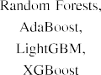
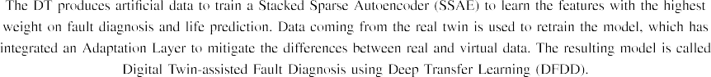
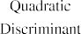
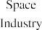

challenge is offered by TL, where the ML model trained with artificial data can be adapted to perform good predictions on a real test set. TL requires that the distributions of artificial and real data be somewhat similar, such that only a small amount of real data is needed to make the model generalise well once deployed in production [44].
Another important use case of ML in DT implementa-tions is remote control assistance. In scenarios such as remote surgery [83], [84] or space station maintenance [85], the DT can help bridge the distance between the operators and the physical twin. In the latter paper in particular, the authors proposed the Hierarchical Attention Single-Shot Detector Network (HA-SSD) for astronaut gesture recognition. The system is based on the popular MobileNet architecture [86] for fast and computationally inexpensive feature extractions, which could be easily deployed on chips with low processing power. Such a system is ideal for space station DTs where cameras and surveillance equipment can detect and monitor faces, human postures, gestures and body language.
Table IV summarizes the findings of integrating ML into DT. It can be noted that most of the efforts towards DT implementation come from the manufacturing industry. Concurrently, the versatility of the technology makes it a promising tool for other domains as well, such as civil engi-neering or robotics. It is actually the vast array of existing and up-and-coming ML and DL algorithms that grants the DT its versatility. At the same time, the DT’s reliance on data-driven
analytics imposes some challenges: (1) traditional ML mod-els are actually built upon a sequence of carefully engineered functional blocks that are tailored to increase efficiency on the task at hand. Thus, designing such a pipeline can be a resource-expensive task; (2) on the other hand, end-to-end DL techniques remove some of that complexity, but they require significant amounts of data for training and tuning, while also offering no transparency into their predictions; (3) finally, on the note of training data, generative ML models can be used to create artificial data to compensate for the lack of real data. However this could also induce bias in predictions if the two distributions (i.e., real and synthetic) are not aligned.

- Cloud, Fog, and Edge Computing
Depending on its use-case, DT can be used to mirror systems across the whole spectrum of complexity, from uni-tary elements, such as the movement axis of the Computerized Numerical Control (CNC) machine tool [87], to an entire fleet of aircraft [88]. The virtualisation of composite heterogeneous machines or services always requires heavy computational prowess. This demand, coupled with the DT’s characteristic of real-virtual synchronisation, often calling for almost real-time responsiveness, illuminates a need for distributed and paral-lel computing. For this purpose and many others, cloud, fog, and edge computing are frequently encountered in DT-related literature. As such, this section will review how researchers

TABLE V
Overview of Reviewed Literature Integrating Distributed Computing Into Digital Twin

have integrated distributed computing into their DT imple-mentations, with an emphasis on the reason why this enabling technology was mandatory for the works’ use-cases.
Table V highlights an overview of the papers reviewed in this section. It is noteworthy that our search indicated that distributed computing and DT have been conjoined in works mostly pertaining to the manufacturing sector. Even papers focusing on DTs for logistics are mainly created to help the logistics departments of the manufacturing industry, again showing that there is an overwhelming focus on DT development in this area.
The unison of cloud computing and DT creates a pros-perous environment for complex simulations, multi-variable analysis, DL-based analytics, and Big Data storage. In this type of system, the cloud platform acts as the data ware-house and also provides heavy-processing capabilities, while the DT deals with synchronising the physical and virtual assets [25], [32], [45]. Additionally, a cloud platform allows the harmonious connection and hosting of the virtual counter-parts of the heterogeneous subsystems that form a complex DT [33]. In the healthcare industry, the cloud represents a shared information platform between the medical service provider and the patients [26], while in the manufacturing domain it can serve as a common medium where enterprises can share data regarding the failure modes and maintenance needs of similar equipment to support DT-enabled Predictive Maintenance [89].
In applications that imply a great amount of data consump-tion and processing, even the cloud can become overwhelmed. To prevent this from happening, Hu et al. [90] reduce the cloud workload by using the MTConnect protocol and a new Knowledge Resource Centre to manage all commu-nications with the cloud-hosted DT. Another approach to avoid over-dependence on the cloud is to use more forms of distributed computing (i.e., cloud, fog, and edge) to man-age different layers of complex logistics and manufacturing systems [27], [34].
- Internet of Things
As previously mentioned, the research communities of academia and the industry recognise the DT as a system
formed by three functional blocks: the physical asset, its vir-tual counterpart, and the communication medium that binds them together. Any DT proposal that misses or does not envi-sion the inclusion of any one of these three components is therefore not a real DT. In this section, the focus will fall on the role of the two-way connection between the digital and real twins, and the recent literature works that detail how this connection benefits the implementation of the DT. Table VI provides an overview of the articles discussed in this section, as well as their target domain and main contributions.
In this context, the Internet of Things and the Industrial Internet of Things are the main enabling technologies that can perfectly fit in-between the digital and real twins to converge virtuality and reality. These paradigms are at the center of I4.0 due to their ability to aggregate data from multiple heterogeneous data sources via disparate communi-cation mediums to facilitate data mining and alaytics through distributed computing frameworks.
The main appeal of these technologies is represented by the IIoT devices, like smart sensors, RFID tags, and smart wearables, that are useful and cheap data sources [35] which can paint meaningful virtual reflections of reality that the cloud-based DT can interpret and analyse in order to reduce manufacturing uncertainty and complexity in fixed-position assembly islands [57], optimise the functioning of power equipment switchgear [24], provide PdM for automotive brake pads [46], and visualise in real time the stress endured by metal shelving brackets via Augmented Reality [47]. Other use-cases benefit from these technologies as well, since smart sensors and wearables can also be integrated in mobile equipment that people carry, urban infrastructure, and interior appliances. The richness of heterogeneous data that the IoT sensors bring can be used to virtualise and visualise cities, allowing struc-tural simulations for hazards prevention [48], and to remotely manage safety issues in the workplace [28].
Concurrently, the IoT/IIoT brings more than just data to the DT system. In [91], the DT is built upon the traditional IoT framework, and it is split into two parts: one at the edge, and one in the cloud. Both essentially working also as the gate-ways that connect the two corresponding media of the IoT framework. Furthermore, while the IoT is a powerful enabling

TABLE VI
Overview of Reviewed Literature Integrating IoT/IIoT Into Digital Twin

technology of the DT, the DT itself can also act as a sup-porting pillar for the IoT by providing a self-adaptive and self-integrating digital abstraction of the IoT devices to make the IoT framework resilient to dynamic changes [49], or by allowing virtual simulations of large sensor networks [50]. In the context of IIoT, equipping edge devices with ML solutions can be a challenging task due to the limited resources on the devices as well as the concerns about communications with the cloud (low latencies, raw data privacy). As such, the authors in [93] proposed building a DT of the Edge Network that was able to leverage Federated Learning (FL) to re-train aggre-gated models locally, on edge devices (thus avoiding raw data transmissions), as well as optimize communication efficiency using the DT’s updated mirroring of the network. For addi-tionally improved communication security for the previously reviewed framework, the authors in [94] proposed using the blockchain technology to store the aggregated model parame-ters of the edge devices on the Base Station, making the FL process even more robust to data privacy issues.
Another aspect that IoT contributes with into the DT devel-opment is that it provides a platform that can understand and translate data from multiple protocols. IoT devices are usually built with certain communication standards in mind, like MQTT, CoAP, MTConnect [90], OPC-UA [35], or 5G uRRLC [92], and IoT is a bridge that connects those stan-dards with the higher-level abstraction that is the DT. The choice of IoT devices, communication protocols, and IoT plat-forms can influence a very important characteristic of the DT: the synchronization rate between the real and virtual twins. We have established before that this synchronization rate will depend on the use-case of the DT. For time-sensitive applications, ranging from remote healthcare to traffic manage-ment in smart cities, the communication link between the two entities should include secure uRLLC, while other use-cases where synchronization latency is not necessarily a problem,
like rarely-used manufacturing equipment, this requirement is not so stringent.

- Cyber–Physical Systems
With the advancement towards the digitisation of conven-tional physical systems, the term Cyber-Physical Systems has gained ample attention from the academia and industry. However, in the literature works surveyed in this paper, we have found that there are at least two definitions that fall under the span of the CPS abbreviation, and while they are quite similar in meaning, they still represent different concepts.
In the original vision of CPS, they represent the ubiqui-tous and holistic convergence between real complex systems of heterogeneous systems and their virtual intelligent control instances. The physical space is represented by an ecosys-tem of physical equipment, sensors, actuators, and human operators that labor together towards the same goal. The cyber elements are the virtual representations of the physical components and they offer a layer of intelligence that pro-vides self-configuration, self-adaptation, and self-preservation to each physical instance, to ensure that the ecosystem is resilient to changes and failures that would affect its abil-ity to reach its goals (this paradigm is sometimes referred to as Cyber-Physical Production Systems (CPPS) [95]). In other words, this definition of CPS envisions them as a system of inter-connected DTs so, in this sense, the DT is an enabling technology for CPS. This interpretation of CPS leaves a blurry boundary between CPS and DTs, as they boast similar features and advantages and represent the smooth convergence between reality and virtuality. To clear confusion, a study detailing a comparison and correlation between the two paradigms has been conducted in [36].
The second meaning of CPS is more down-to-earth. In the literature, CPS sometimes refers to physical systems with

TABLE VII
Overview of Reviewed Literature Integrating CPS Into Digital Twin or Vice-Versa

varying levels of complexity that are equipped with built-in sensors, actuators, networking and computation capabilities, and that are controlled digitally via computer-based algo-rithms. It is clear that such CPS, compared to the ones in the previous definition, require a lower level of intelligence and digitalization. However, they do represent an enabling tech-nology for the DT, given that they are I4.0-ready physical equipment that are proficient in reliable data acquisition, pro-cess optimization with feedback inputs, and improved built-in monitoring and control capabilities. Such CPS are an asset for DTs to gather data securely from the physical processes and perform regulatory control operations at the edge.
In the works that reference the first definition of CPS, the authors rely on a generic architecture of CPS onto which they build the DT [51], [59]. As such, the DT makes use of the CPS-specific Service-Oriented Architecture (SOA) and act as Cyber-Physical System Nodes [29] in the virtual ecosys-tem, or it assures managerial independence of heterogeneous interconnected systems [37].
The articles that interpret CPS according to the sec-ond definition provided above use the computer-controlled system as the physical counterpart of a virtual twin. These works dive deeper into the implementation of adaptable DT simulations via Functional Mock-up Units [52] or GA for scheduling optimization [53]. Others use the CPS-integrated Manufacturing Execution System (MES) software as a down-link between the virtual twin and the physical CPS [38], or leverage the DT to facilitate, control, and monitor highly complex material flows [54].
Table VII summarizes the contributions and advantages of the literature works revised in this section. Again, the bulk of CPS-integrating DTs comes from the manufactur-ing industry, where significant efforts have been made to turn conventional factory equipment into CPS by populat-ing them with sensors and connecting them to their vir-tual twins that generate intelligent insight. The SOA, which is a founding principle of CPS, serves as a decoupling
strategy that allows DT services to interact independently and efficiently.

- Virtual Reality and Augmented Reality (VR/AR)
The Digital Twin’s goal of virtuality and reality convergence seems to perfectly align with the driver behind two developing technologies: Virtual Reality and Augmented Reality. Indeed, VR aims to improve Human-Machine Interactions (HMI) via 3D computer-generated simulations with which the user can intuitively interact through wearable electronic devices. In other words, VR can help immerge human operators into a digital environment. On the other hand, AR technologies make use of wearable devices render 3D digital images onto a real-world background. In essence, AR helps bring vir-tual information in a physical environment. This section will explore how researchers have leveraged these two cutting-edge technologies to drive forward the DT paradigm.
In the healthcare industry, Laaki et al. [56] created a DT of a remote surgery environment. The virtual representation of the medical equipment in a given location can be accessed via VR by health professionals from a remote location. In turn, wearable devices (head-mounted displays) allow the doctors to control a virtual robotic arm that operates on a dummy patient. The DT then synchronizes the real and virtual twins of the robotic arm, such that the user can directly and intuitively control the physical asset via its DT.
Besides immersive and remote control of the real twin, VR also enables human operators to interact with the virtual twins of industrial equipment as they normally would with the equip-ment itself, without interrupting the normal functioning of the real entities. As such, engineers can devise new deployable Circular Economy strategies to be implemented on the real twin once thoroughly tested in the virtual world [96], create high-quality artificial training sets for safety training in sce-narios where real data acquisition is risky or costly [97], or have students and trainees learn how to operate the physical

TABLE VIII
Overview of Reviewed Literature Integrating VR/AR Into Digital Twin

twin by immersively interacting with and practising on their DTs [98], [99], [100].
AR technologies can facilitate quick access to the DT interfaces of real entities by superimposing their virtual data and images onto the camera feed [101], when the camera is pointed at the physical twin itself [102]. This feature allows human operators to dynamically monitor DTs, without having to go out of their way and connect to the computer that hosts them.
According to one study [103], the VR/AR-enabled DT can address three current challenges in HMI development: high-fidelity virtual representations of physical assets, availability of both real and simulated data, and intuitive interfaces for human operators. However, for a complete merge between the real and virtual worlds, neither technology is enough by itself. Both technologies allow the user to interact with the virtual repre-sentation of a physical entity, but they do not allow the real and virtual surrounding environments to interact with each other. For such cases, Mixed Reality (MR) technologies combine the advantages of both VR and AR, to bring digital models in the physical world and simulate their processes under real cir-cumstances [104]. Table VIII summarizes the main findings of this review, highlighting the main domains where VR/AR/MR technologies have enabled the DT to provide immersive HMI, training and monitoring.

- Modeling Methodologies
While not an enabling technology in-and-of-itself, the umbrella of modeling methodologies covers a great range of frameworks and software meant to guide developers towards building a core component of the DT: the virtual representa-tion of the physical entity. Similarly to the DT definitions, the modeling approaches also vary greatly across the literature, that some researchers concluded that there is no consensus on the subject [13], [105]. The challenge to overcome here sits in the interdisciplinary and use case-specific nature of the DT. It is indeed difficult to create a one-size-fits-all architecture for such a versatile technology, given that its application scenario
can impose significant alterations to that architecture. This is also part of the reason why the DT is also difficult to define. For example, it is not always the case that the physical twin is an actual, real object, characterized by a physical geom-etry. As such, proposed modeling methodologies that imply the existence of a physical object would not map well to use cases like the DT of processes. On this note, the authors in [106] proposed an architecture for the manufacturing indus-try that breaks down the DT into three constituents, namely product DT, process DT, and operation DT, with each com-ponent having a seemingly different architecture. A different modeling methodology, presented in [107], summarizes a man-ufacturing DT as the synchronization between 3D modeling and mechanism modeling.
Nevertheless, researchers in the field have come up with DT frameworks that abstract away from the use case-specific details of implementing. Instead, they take a step back in order to focus on the components one could reasonably expect to find in any DT, no matter the application scenario. The authors in [108] claim that a DT only requires two main components to be whole, which are: a virtual representation of the physical entity and an API. The authors also men-tion that the virtual model does not require to include the 3D geometry of the physical object, unless that is required by the DT’s use case. In addition, other dimensions can be added to the DT, such as: data storage, access control, meth-ods, events, and a human-machine interface. Similarly, other works [109] insist on the importance of creating an API-like middleware that allows the DT to connect to external systems. Riedelsheimer et al. [110] proposed a methodology for build-ing DTs for already-built, complex, inter-disciplinary physical objects, with the aim to optimize the systems’ sustainability throughout its lifetime. With the goal of creating the DT of a smart factory able to manufacture customizable products, the authors introduced a planning and development framework that integrates several design and management frameworks, such as V-IoT, 8D-Model, Design Elements, SCRUM, etc.
A more common approach to modeling methodologies that can be found in the literature is the 5-dimensional DT initially

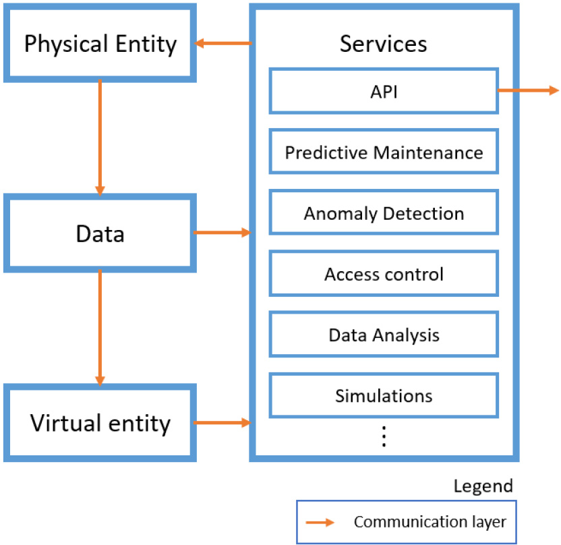

Fig. 5. Five-dimensional DT architecture.

proposed by Tao et al. [111]. According to this work, the five dimensions of the DT are: physical entity, virtual entity, communication, data, and services. This break-down of the paradigm allows for a decoupled architecture with orthogo-nal elements, making it easier to understand. For this reason, many researchers have based their modeling methodology pro-posals on Tao’s work. Wang et al. [112] build on top of the 5D DT to introduce a System Design Digital Twin which aims at reducing the complexity of model-based system engineering by closing the gap between the physical and theoretical design processes. The authors in [113] proposed a DT information modeling method dubbed GHOST (Geometry, History, Object, Snapshot, Topology), representing an expansion of the data element of Tao’s architecture. Its aim is to provide a flex-ible framework for combining multi-source heterogeneous information in complex DT systems. Wu et al. [114] presented a methodology for building 5D DT models that is supported by an improved version of the TRIZ function model. The TRIZ function model describes a complex system by breaking it down into various types of elements and relationships. In order to provide further nuance and fidelity to the model, the authors enhance TRIZ with behavioural logic via conditional flow control, rules, and interactions with the external environment. Finally, other existing architectures partially overlap with Tao’s methodology. For example, Bazaz et al. [51] defined the DT as an interconnection of five layers: data store layer, primary pro-cessing layer, model and algorithms layer, analysis layer, and the user interface component. Judging by the description of each layer provided in the paper, Tao’s data dimension cor-responds to Bazaz’s data storage layer, the communication element is similar to the primary processing layer, elements of the virtual entity dimension can be found in the models and algorithm layer, while Tao’s services element, it can be argued, includes both the analysis and user interface layers.
Abstract modeling methodologies have seemingly slowly begun to converge in the DT-related literature around Tao’s 5D model, depicted in Figure 5. However, the in-depth imple-mentation details and technologies remain use case-specific.
In [115], the authors took a closer look at the specific frame-works and software that can be used for DT development.

- Digital Twin: Use Cases and Services
As we have stated previously, the choice of enabling tech-nologies for the DT will be highly dependent on the DT’s envisioned applications and services. In this section, we will present how DT frameworks differ in their components from one application scenario to another, and it will become appar-ent how, even within the same use case, the DT structure can vary greatly. As such, this section will be divided into two cen-tral characteristics of the DT, as presented in the definition we provided in Section II, namely DT use cases and DT services. There are many potential DT services and use cases; however, within this section, we limit our survey and discussion to some typical examples in each category to demonstrate the concept and potential of the DT. This choice of DT services and use cases also align well with the specific case studies we present in Section VI.

- Use Cases
  - Smart Factory and Industry 4.0: The current vision of I4.0 aims to cut the costs of production, build efficiency and give companies an increasingly versatile approach to produc-tion. Factory stations now have the ability to communicate directly with one another, eliminating the need to commu-nicate via a central processing controller. This decentralisa-tion through modularisation and the IoT increases flexibility, opportunity and efficiency. Rather than a centralised control unit delivering instructions to each machine to carry out linear sequential steps, individual machines now inter-communicate directly enabling the partly-finished product to be passed straight on to the next station. As everything is now processed locally, the production line is equipped to produce any num-ber of unique products, which was not previously possible on single unit lines. By not having to communicate with a cen-tralised unit, the production line can run more smoothly and efficiently. In addition to increased efficiency, the new secu-rity sensors built into the autonomous modular systems create a safe working environment for human operatives, ensuring robots halt if they encounter an obstruction. This has the added benefit of workers being able to touch a robot to stop its motion without the need to activate an isolator. The decentral-ization of manufacturing processes and the increasing demand for customization leads to a need for adaptive and intelligent production equipment. The DT aims to address this challenge. Makarov et al. in [116] investigated the design concept of a DT, coining two new types of system and splitting the def-inition of a DT into four parts. A pre-DT is defined as a virtual prototype for a system to reduce technical risks and root out design problems before development. Any issues with the system found on the virtual twin can be solved and corrected on the physical system. An adaptive DT uses a user interface, linking the two systems, allowing the virtual twin to understand the preferences from the human oper-ators in different scenarios. Finally, an intelligent DT has all the characteristics mentioned before; however, it contains

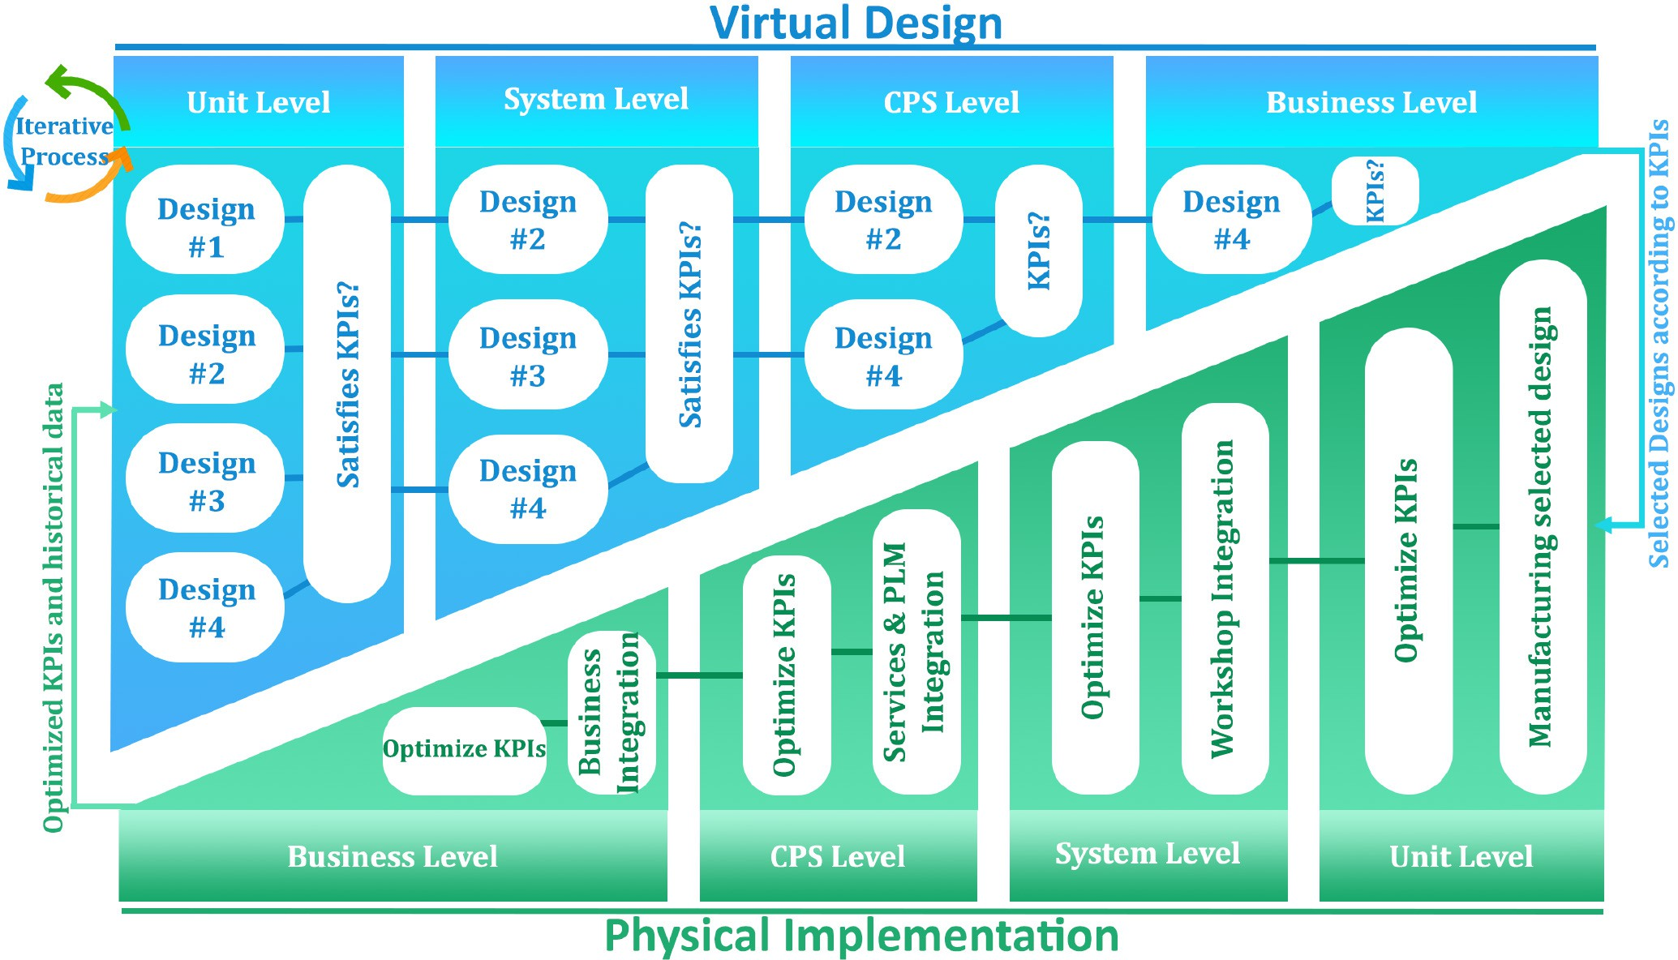

Fig. 6. Digital Twin framework for smart manufacturing.

unsupervised ML for pattern detection in the physical system environment. The results found to reduce repair costs and increase quality control for a lowered amount of product defects.
Lee et al. in [117] proposed a DT framework for smart manufacturing. More specifically, the authors introduced a sys-tematic integration of the DT in various levels of shop floor design: unit level, system level, CPS level, and business level. Figure 6 displays the workflow of the proposed architecture: shop floor designs are initially tested against unit level Key Performance Indicators (KPI) and are only selected for the subsequent level testing if they satisfy them. Consequently, a triage-based system filters out the designs that do not meet KPI requirements at each level during the virtual implemen-tation of the shop floor. In the physical space, the selected designs are implemented gradually across all levels, and the real performance of the designs help optimize the KPIs in the virtual domain.
In [118], Preuveneers et al. proposed the use of safeguard-ing systems throughout the software of the DT system. These safeguarding systems, coined “software circuit breakers,” are designed to handle local system errors to stop faults propagat-ing through the levels of the DT, as these have the potential to be catastrophic. Such local failures can include:
    - Missing sensor data
      - Failed transmissions
      - Disconnected sensors
    - Broken Sensors
      - Hardware failures or disconnected actuators
      - Denial of service attacks
The results show that the addition of software circuit break-ers in DT systems can station errors cascading into higher-level systems, and keeps the fault local to that physical station. The goal of this, however, is not directed at stopping the spread of errors, more to isolate them, as different errors hold different levels of severity.
In [119], Lee et al. investigated a DT-enabled predictive maintenance framework for a CNC machine tool system using DL. The authors outlined vital design characteristics and requirements for integration of DTs in a CPS. The rapid growth and requirements for IoT and ML mean data trans-fer latency has to be as low as possible. The authors suggest 5G will significantly contribute to the integration of ML and be the backbone of DT technology. They also indicate that all sensors should be developed into smart sensors for ease of plug and play and scalable networking.
Gericke et al. [120] investigated the efficiency and latency of communication and production rate of 500ml water bot-tles with a cyber-physical bottling plant. Using Open Platform Communication (OPC), they were able to give possible posi-tions of bottle-necks in production. Using this, the DT can also detect drops in production rates. The authors conclude by pointing out the machines cannot rely on OPC as the only con-nection to the physical system due to the significant latency, ranging from 100ms to 500ms. They also found that as the system scales, more OPC connections will be needed, further slowing the system.
Lin and Low [121] carried out research on the design and implementation of a DT on a CPS. The authors suggested there are three layers of modules required to produce a DT system:

    - Operation Layer—used for tracking all physical assets on the CPS
    - Visualisation Layer—used for real-time simulation, tak-ing the data gathered from the operation layer and provides a remote-monitoring function to allows com-panies to be continuously updated on current production status
    - Intelligence Layer—This takes all the information from the previous two layers to create a historical data bank. This layer will use this data bank, along with real-time data, to perform efficiency and health monitoring.
The authors then took this design concept, implemented it onto a prototype Surface Mounted Technology production system, built of seven stations. This system worked and acted as a validation to their prosed three-layer DT design concept. Hasan et al. [122] investigates the use of blockchain tech-nology as a way of optimising the DT format on a CPS. The problem outlined in this paper is with the development side of DTs. There is a need for monitoring the interaction between design teams and workflows, so each change made to the software can be accredited to a specific person, who can be held accountable. This employs transparent history moni-toring, security and trust and ensures the trusted creation of virtual models. The blockchain platform used was Solidity -
Ethereum smart contracts.
In [123] Kanak et al. presents a blockchain-based model for distributed and collective DT environments which is becom-ing essential in new “Any 4.0” era. They proposed a novel approach to use security as a symmetric and asymmetric cryp-tographic tool to be implemented at a hardware level. The DT ecosystem proposed includes “X-by-design” and “X as-a-service” principles where “X” is security, accountability and integrity.
Similarly, the authors in [124] developed a simulation-based CPS DT for blockchain enabled Industrial Hemp Supply Chain (IHSC), which is utilized to improve the understanding of a complete process pf supply chain, assist in quality con-trol verification and fast track the development of secure and automated supply chain system. They present the two-layer blockchain based data tracking, information sharing, and inter-operability framework for the end-to-end IHSC which can greatly improve both security and efficiency.
In [125] a DT for an experimental assembly system based on a belt conveyor system and an automatized line for quality production check is proposed. They have created a DT for Bowden holder from a 3D printer, which is composed of some plastic components, fastener parts and a stepper motor. The assembly was positioned in a fixture with ultra-high frequency tags and IoT devices for identification of status and position. The inspection system included an industrial vision system for checking presence of parts, inspecting the dimensions and looking for errors before and after assembly operation.
Vachálek et al. [126] presented a DT model of the produc-tion line based on the simulation tool called Plant Simulation, made by SIEMENS. This model was a detailed virtual copy of the physical process involved in assembling the hydraulic pistons. The goal was to extract the information about the number of times there has been movement, to the data storage
and OPC data server of SIEMENS have been used to process this information transfer.
  - Infrastructure: Civil infrastructures are highly valuable assets, having vital societal roles and involving a large number of people at every stage of its complex working life from initial conceptual drawings, 3D numerical model, construction activities to operational service, as shown in Fig. 7. Thus, infrastructure management has been a sub-ject of intense research activity, aiming to maximize their safety and service life while minimizing the building and maintenance costs. In the following section, recent works investigating DT-based paradigms unifying practical tools and expert knowledge with novel advanced technologies are reviewed. Furthermore, a DT application for Structural Health Monitoring developed by the authors will be described in Section VI.
- Smart Building: A building consists of a number of com-ponents spanning different domains from energy, ventilation, heating, air-condition, plumbing, mechanics, and so on. Thus, having effective building management is challenging, espe-cially with a high-rise building or a commercial complex. Therefore, Lu et al. [127] have developed a smart O&M man-agement tool using DT specialized in detecting anomalous behaviors. At first, a dynamic and distributed data integration component was built to integrate heterogeneous data from var-ious daily-updated databases using corresponding object IDs. Secondly, intelligent anomaly detection functions were imple-mented using the BOCD to identify suspected change points, related time instants, locations, and even elaborate the causes of the change points.
Lu et al. [128] have developed a dynamic DT in order to improve asset maintenance and asset failure prediction in a campus of the University of Cambridge. The DT framework consists of five layers: (1) first, acquisition layer collecting data from multiple sources including Building Information Modelling (BIM), real-time IoT sensor data, asset registry, and asset tagging data and space management data; (2) second, transmission layer transmitting data collected from physical device in the first layer to a central database using WiFi, 5G, low-power wide-area networks, etc.; (3) the third layer is digital modeling, where different types of digital models could be developed for various requests in DTs; (4) fourth, the data/model integration layer provides real-time analysis, then assess up-to-date asset condition and maintenance status with the help of AI-based functions; (5) and lastly, the application layer with visual interface facilitates the interaction between DT and facility managers.
Thyssenkrupp, in collaboration with Microsoft [129], developed a DT framework for the elevator system in a high-rise building in Rottweil, Germany. The new advanced elevator, which could move both vertically and horizontally, was equipped with IoT systems and deployed via the Azure DT framework. This DT is able to reduce the downtime of the elevator significantly, provides information related to elevator occupancy and usage to enhance the availability of the eleva-tor, which serves more than 10,000 people per day. Moreover, the DT is reinforced by AI learning to optimize travel times of frequent users.

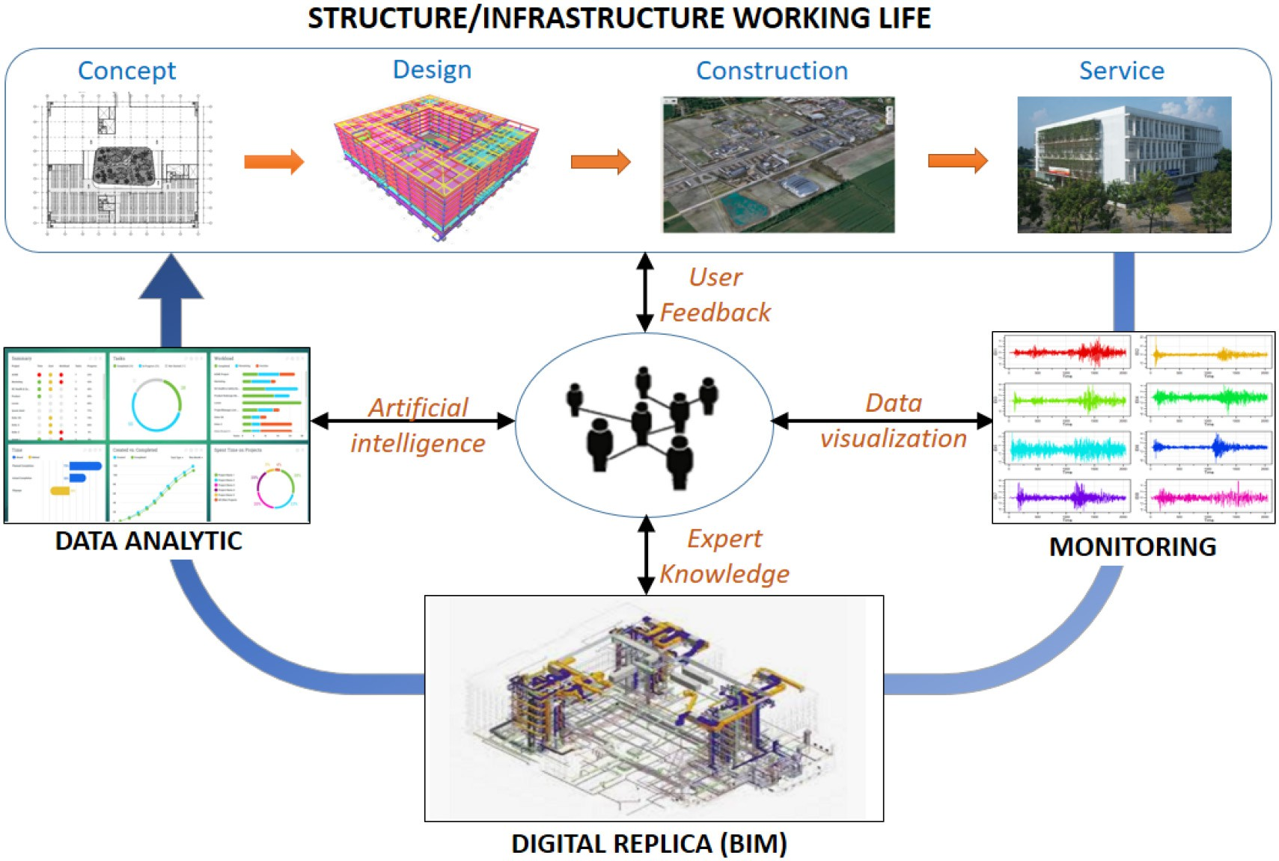

Fig. 7. Digital Twin in infrastructure.

- Smart Infrastructure: Ganguli and Adhikar [130] thor-oughly presented a DT for a Single Degree Of Freedom (SDOF) dynamic system, in which a double time-scale system was proposed the first time. Specifically, the fast time scale reflected the dynamic responses of the real system and the slow one for the DT, and it was found that such a multiple time-scales DT was able to capture effects of mass and stiff-ness evolution on the SDOF simultaneously. Ding et al. [131] proposed a DT for a steel bridge construction using BIM and IoT data from embedded sensors, able to dynamically monitor the construction processes and key related factors such as site resources, business processes, field workers, as well as their live interaction, thus ensuring a lean construction.
In order to develop a proactive maintenance system for bridge structures, Shim et al. [132] proposed twin models fus-ing entire lifecycle information from design, construction to operation, and maintenance. The first model was built from as-built documents using BIM, while the second model was generated with the help of the 3D scanning technique using Unmanned Aerial Vehicles and laser scanner. A maintenance-oriented digital process connecting two models was also elaborated to update the structure’s status continuously.
Structural Health Monitoring (SHM) is an important topic in civil engineering, thus Ritto and Rochinha [41] explored a SHM-oriented DT. Essentially, data-augmented modeling is implemented to compensate for the discrepancy between numerical models and physical counterparts, which involves two phases. First, the discrepancy is qualitatively and quan-titatively measured from the physical entity. Second, bias-corrected models are calibrated based on the numerical model and measured discrepancy, yielding augmented outputs which
closely approach the real behavior of the structure over its working life. Another concrete example of DT application in SHM is the work of Kaewunruen and Xu [133] for rail-way turnout systems, which consists of many delicate and complex details and has a critical role in ensuring the safety of the railway system. The application is built by expanding the conventional 3D BIM models to 6D models, involving three geometric dimensions, time dimension, cost dimen-sion and its sub-categories, and carbon footprint dimension. Moreover, not only actual operation information are inves-tigated, but data from historical phases such as planning, design, pre-assembly to predicted future action, i.e., mainte-nance, demolition are also taken into account. A similar DT approach via 6D BIM is applied to the renovation manage-ment of the King’s Cross station [134], aiming at a more resource-economic and environment-friendly model than tra-ditional construction methods such as 2D paper drawings, or 3D static numerical models.
With regards to the offshore structures, Akselos [135] has developed a holistic DT framework coupling with parallel cloud computations, which can provide real-time risk-based decisions in response to time-varying uncertainty encoun-tered by offshore structural engineering involving wave, wind, marine environment, and so on. As one of the leaders in the power plant industry, General Electric has been devising a sophisticated DT framework, a.k.a. Predix, [136] including a spectrum of aspects of the physical entity ranging from thermal, mechanical, material, electrical, economic, statistical, environmental. This DT is expected to perform a wide range of applications such as optimizing profitability, maximiz-ing plant safety, accurately forecasting productivity, profiling

customers, synchronizing operations of many machines on plants. For this purpose, various advanced technologies have been implemented in Predix: firstly, multimodal data analyt-ics are required to automatically collect, update, and store a vast amount of heterogeneous data involving: parametric data (temperature, pressure), graphical data (infra imaging, cam-era), spectral data (spectroscopy), time-series data (sensors, accelerometers), text data (service records), historical data (maintenance database), and so on. Secondly, the company deploys a number of digital models encompassing physics-based models, i.e., thermodynamic model, combustion model, transient dynamic model, and data-driven models such as sta-tistical process control, ML-based anomaly detection, and DL regression and classification. Finally, a knowledge network, called Expert Twin is explored to connect experts across the enterprise around the world for sharing data, knowledge, solution, and best practice.
- Smart City: In an attempt towards sustainable growth of the city as well as a better quality of life for citizens, Francisco et al. [137] investigated a DT paradigm for Smart City using spatio-temporal data. At first, a digital replica of the city is rebuilt in a virtual space using the Unity cross-platform; after that, the researcher can navigate across the virtual city via VR devices. In addition, an AR crowd-sourcing module allows for integrating feedback of citizens about real infras-tructures into the platform parallelly. By doing so, the triangle interaction human-infrastructure-technology is captured, ana-lyzed, and updated, serving to improve the sustainability and wellness of the city.
Ruohomäki et al. [138] explored a Smart city platform using DT for the city of Helsinki to enhance city management in var-ious aspects, including urban landscape, energy consumption, environment. At the base of the platform is the 3D city models called CityGML integrating geographic information, geome-try, topology, and appearance. Next, sensor data are linked to city models via an IoT platform called SenSorThings, com-posed of two main parts: sensors for observation and thing, i.e., API, for connection to the network. By doing so, the initial 3D model is transformed into a semantic ecosystem with high interoperability. Du et al. [139] presented a Proof of Concept of DT for Smart City’s Information System at an individual level, namely, Cog-DT, to reduce the cognitive overload for residents and workers in the city. The first step of Cog-DT involves using VR technology to gather personal cognitive information such as neuroimaging, physiological, ergonomic. Then, the second step is to simulate human cog-nition in response to various information stimuli. Finally, an adaptive information system is implemented to display engi-neering information adjusted in a real-time fashion. In an attempt to improve the long-term performance of the O&M service of building and other infrastructure, Lu et al. [140] developed a 5-layer DT architecture and applied it to the West Cambridge site with more than 20 buildings and other facil-ities. The proposed DT architecture can be extended further up to a city-sized application. Their five main layers are data acquisition layer including sensor data, weather, energy, secu-rity, culture, policy data and so forth; transmission layer via the Internet, 4G/5G, HTTP; digital modeling layer with the
help of BIM, energy simulation model, weather simulation model; data/model integration Layer powered by data analytics and AI; and finally service layer providing multiple services such as energy management, asset management, security man-agement, etc. at different levels for different stakeholders. Lin and Cheung [141] explored a DT application for Smart City’s underground parking garage using Wireless Sensor Networks (WSN) in conjunction with BIM technologies for improving environmental management. The WSN was com-posed of various sensors able to monitor gas, temperature, the humidity of the garage, whose data were later transferred to a central host with the help of communication routers. On the other hand, a BIM model of the garage is built by Autodesk Revit and Naviswork, providing a detailed digital representa-tion. When coupling the BIM model with environmental data from sensors, the risk status, i.e., CO gas level, user comfort level, are lively represented and can be visually noticed with green/red color code.
  - Towards 5G/6G With Digital Twin: The future Industry
5.0 paradigm envisages removing any physical limitations and building in virtual connectivity and capabilities that will enable the seamless interaction between devices, humans and infras-tructure [142]. Even though this digital transformation across various industries will enable applications that serve different purposes, they all have something in common: dependency on reliable and strong connectivity enabled by the underlying next generation network infrastructure (e.g., 5G/6G). The fifth generation networks is already a key component in I4.0, since, even in the DT technology, the connection of components and devices is of utmost importance and communication latency is expected to be less than a few milliseconds. In this context, the relationship between 5G/6G and DT can be seen from two different point of views. The first one, sees the 5G/6G network as an enabler for different DT applications, while the second one sees the DT as an enabler for 5G/6G by looking at the DT of the network itself. Both point of views are addressed in this section.
Communication technology is going to be the foundation of industrial IoT, hence in [143] authors have presented a detailed overview of 5G wireless transmissions and their application prospects according to cyber-physical-based manufacturing systems. Furthermore, a novel 5G-based industrial IoT archi-tecture for smart manufacturing is proposed. In [144] authors have taken an industrial robotic arm as a use case and have performed an analysis of simulated robot with the effects of simulated network for CPPS. The key contribution of the study is the comparison and analysis of effects of using different kinds of network types in a Gazebo simulated robot. The three types of networks used between robot controller and robot are wired link, public LTE and the 5G uRLLC network. The results showed that 5G outperforms LTE and wired network in terms of productivity as well as the processing time increased by 50%.
Furthermore, 5G (and beyond) and the DT can revolution-ize the cooperative vehicle infrastructure. The authors in [145] have explored the implications of 5G based communication to the intelligent V2X system called Providentia and proposed scene detection, fusion and object detection strategies. The

vehicles in the Providentia system play two roles, first being the source of information about the current state of vehicle and its surroundings, second as a user of the DT system. All the communications in this infrastructure is realized through on-board 5G modems as well as 4G LTE. Similarly in [146] 5G communication networks, more specifically edge devices, are recommended for the real time data collection in DTs designed for traffic congestion avoidance. The proposed solution for road connectivity infrastructure involves real time situational information gathering, collection of driver history using ML algorithms, data lake, intelligent transport system, DTs and blockchain services for vehicles. The application domain of the DT technology is very vast, as the authors in [39] have optimized the services of mobile edge computing using DT and DL algorithms. Achieving ultra-reliable and low-latency in mobile edge computing can be challenging because of the possibility of losing the packets in case of deep fading chan-nels. Thus, in order to optimize the offloading probability, a DT is developed in [39] which can evaluate the normalized energy consumption, reliability of user association schemes and delays. The DT will save the optimal option and store it in memory as a training data for DL algorithms. Tactile Internet or 5G will also revolutionize the traditional multimodal appli-cations. Research has been carried out to evolve the current state of the art media to multimodal media, where DTs can facilitate the high quality interactions, like touching and smelling the objects of remote environment [147]. Moreover, the DT and 5G/6G will also play a vital role in autonomous navigation systems [148] where autonomous ships can easily be commanded and decisions regarding navigations are made easy.
Smart manufacturing is one of the most important verti-cal industries identified by 5GPPP and with the maturing of network virtual functions and 5G, use of Virtual Network Functions (VNF) in smart manufacturing is gaining popu-larity in research community. To this context the authors of [149] have presented a use case in the manufacturing indus-try using the experience of a manufacturing company named Weidmuller Group. The manufacturing network services in the proposed use case are composed of different VNFs and it is developed using SDK and 5GTANGO lightweight Network Function Virtualization (NFV) prototyping platform. Similarly, in [150], an efficient solution is proposed, called MIGRATE, that implements virtual functions and virtual mobile devices to represent physical processing devices. MIGRATE ensures the successful and seamless transfer of software entities. Connectivity in the future is highly dependent on develop-ment of DT environments [151] that are actual representation of their physical counter parts. With the advent of future gen-eration networks, it is expected from the DT technology to represent not only physical objects, but the biological world as well.
With the rapid advancements in smart technologies and applications like holographic projection, VR, AR as well as mission critical applications like remote surgery, that have strict Quality of Service (QoS) requirements, current networks including 5G will no longer be able to meet these expec-tations. Although the deployment of 5G networks is not

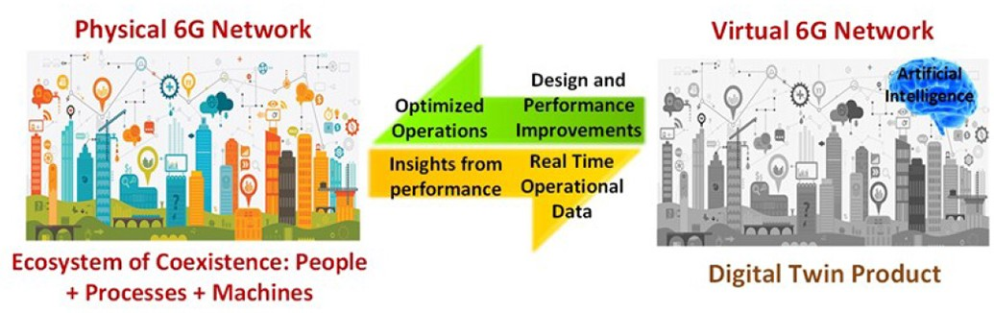

Fig. 8. The vision for DT-enabled next generation communications.

yet completed at a large scale, many industry pioneers and technology leaders are looking ahead at defining the next generation networks, 6G. 6G envisions interactions between three worlds: the human world (e.g., senses, bodies, intelli-gence, etc.), the digital world (information, communication, computing, etc.); and the physical world (objects, organisms, processes, etc.) [152]. Furthermore, 6G envisions network speed of 100 to 1000 times faster than that of 5G for accom-modating new service classes like further enhanced mobile broadband (FeMBB), ultra-massive machine type communi-cation (umMTC), and enhanced ultra-reliable and low latency communication (eURLLC) [153] and latency less than 1ms for ensuring safety in mission critical communications and IIoT applications [154]. DT has great potential to provide for a digital environment where future generation networks like 6G can evolve. Integrating DT within mobile networks is gaining popularity in the industry from major tech compa-nies like Ericsson, Huawei and Nokia [155]. In this context, DT has the capability to continuously monitor and analyze the performance of the network, predict any unanticipated failures and optimize the network performance by triggering intelli-gent decisions accordingly. Figure 8 illustrates a vision of the 6G DT that facilitates the live virtual replica of the whole or parts of the 6G network to perform continuous monitoring and assessment through a closed loop process between the physi-cal entities and the digital counterparts. The 6G DT powered by AI will enable design and performance improvements and real time optimized operations enforced on the physical 6G network.

- Services
  - Anomaly Detection: The Digital Twin has gained its sig-nificance in I4.0 by virtue of its intuitive and insightful role in integrating data analytics into traditional manufacturing facil-ities[15]. Through the analysis of run-time data incurred from the physical systems, DTs have enabled smart factories’ engi-neers to know their facilities better. One of the many strategies involved in analysing the data and discovering better insights is Diagnostic Analytics (DA), i.e., having a profound look at the data to observe and interpret the causes of events and behaviors. An effective and popular technique recognized for DA is anomaly detection [156]. Anomaly detection is a tech-nique of fault diagnosis that detects sections of data disobeying the normal, expected behaviour [157], [158]. The DT-enabled anomaly detection has proven itself an asset for the Operation and Maintenance (O&M) phase of smart factories. As illus-trated in the subsequent literature, it is clear that incorporation

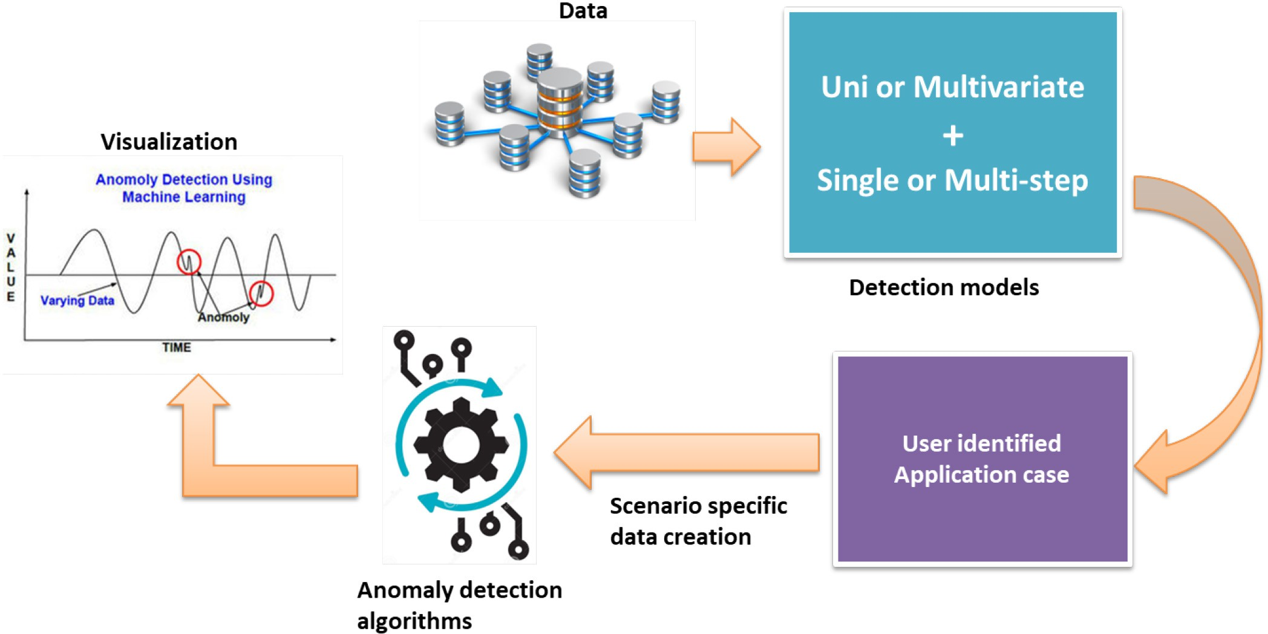

Fig. 9. DT application: Anomaly Detection Framework.

of anomaly detection in DT architectures has had a significant impact on the popularity of DTs in the I4.0 ecosystems.
The anomaly detection work flow followed by researchers in general is represented pictorially in Figure 9. Workflow of Anomaly detection application with most common key phases involved are shown in the Figure 9. It is observed that uni vari-ate or multi-variate models with single or multi step detection models have significant effect on Anomaly detection appli-cations performance. The primary sources of data for such anomaly detection applications are derived from industry run-time data from the connected IoT devices or historical data from database logs available. The DT models close to their physical counterparts in an industry may also simulate the data required along with the run-time and historical data avail-able.Data set identification and creation based on the user specific applications is also determining factor to improve the performance of the anomaly detection application. Anomalies can be visualized with a right choice of algorithms based on standard machine learning models. The choice among super-vised, unsupervised and semi supervised learning models is based on the availability of labelled data versus large data requirements for the training. The DT application can arrive at the next level PdM suggestions from the observations derived from the anomaly detection outcomes shown in Figure 9.
In [159], the authors proposed an IoT-enabled “Living Digital Twin” for additive manufacturing. The twin essen-tially rooted for assuring higher productivity by monitoring the system with analog sensors such as acoustic, vibration, magnetic, etc. The basic protocol might seem rudimentary due to the sensor-actuator action involved, but the twin had a significant contribution in the aspect of anomaly detection. The digital counterpart introduced the concept of a fingerprint library to detect anomalies. The fingerprints are the run-time
values of asset parameters that compared with the instanta-neous IoT data from the physical systems to detect potential anomalies.
A DT-enabled anomaly detection mechanism was proposed in [127] for built asset monitoring. The detection process asserted the need for cross-referencing the multiple data sources for building facilities information. Owing to the data inter-operability and re-usability aspects of the task, DT was accepted as a comprehensive solution for the data integration problem. Storing the data from heterogeneous sources into a single, integrated format eased the detection process, meant for every key asset in the building structure. The run-time data of the assets, acquired in various data forms, was encapsulated in a single data format that invariably assisted the detection process many-fold.
An extensive amount of research has been followed up in implementing anomaly detection with various ML algo-rithms. As a consequence, several research problems have been encountered by the researchers. Castellani et al. [160] implemented anomaly detection on industrial data with a semi-supervised learning approach. The dataset under study consisted of a major portion of unlabelled data (unsupervised learning) and a smaller portion of labelled data (supervised learning). The choice of hybrid dataset for the said study was influenced from the following facts: i) for the supervised approach, additional efforts need to be invested in labelling the data that is prone to be impractical for larger datasets, and ii) an unsupervised algorithm learns by the means of bulk statistics of majority behaviour, thus a smaller unlabelled dataset might result in an ambiguous output. A DT frame-work, by virtue of its simulation capabilities, generated the unlabelled portion of dataset with normal samples that simu-lated normal industrial operation. The latter half of the dataset

comprised of anomalous samples derived from a real factory data. The article claims to have achieved a higher score in its performance indices for semi-supervised approach than the fully unsupervised approach (AUC scores 0.872 and 0.756 respectively). Bevilacqua et al. [161] proposed a reference model using DTs for risk assessment analysis in industrial process plants. They put forth a framework for a smart fac-tory that would enhance its productivity while prioritizing the safety of human operators. The risk identification and assess-ment aspect of the model called for inclusion of an “Anomaly Detection and Prediction” tool in the twin. The tool was developed while being fairly inclusive of the twin-enabling technologies: i) development of a communication and control system with sensors-actuators at the edge and Programmable Logic Controllers (PLCs) at controller station, where the wire-less sensor networks helped to gather the ground-level data to the twin, ii) development of ML models by employing the received data to analyse, predict the risk factors and edu-cate the DT to invoke precautionary actions. Notably in [88], a framework was proposed for the monitoring and diagnos-tics of a fleet of aero-engines. The framework implemented anomaly detection for fault detection, isolation and identifica-tion. A physics-based model of a three-shaft turbofan engine was developed and simulated in-house. The simulation data for the said model and the signatures of potential component faults were generated by a DT. In order to simulate an entire fleet of engines, production scatter simulation was implemented by the twin that cloned multiple replicas of the engines with minimal random variation.
The capability of DTs to analyse temporal data in real time has proven to be a greater asset for targeting spurious events. This statement has been validated by Xie et al. [162] who have proposed a DT framework for crucial asset monitor-ing in a building facility. The multi-layered twin architecture mainly featured: i) the Digital Modelling layer that acquired time series data in real-time and stored simulation data as well as historical data, and ii) the Data/Integration layer that analysed the data at hand and took informed decisions. The said analysis was assisted by the Bayesian Online Change-point Detection (BOCD) algorithm that detected suspicious instances upon investigating the sudden variations in the time-series (change-points). The framework has been demon-strated in a DT demonstrator laboratory at the University of Cambridge. The experiment was conducted on two iden-tical cooling pumps for vibration monitoring and the twin successfully identified anomalous vibrations. On the similar lines, a group of researchers put forth a blueprint for a uni-fied DT for anomaly detection in Smart Manufacturing [163]. A novel aspect of the said architecture was a DT platform consisting multiple twins for every crucial process/entity. A demonstration on a CNC facility proved the significance of an anomaly detection scheme developed by framework. A range of limits is devised by the twin after thorough anal-ysis of historical data. The instantaneous values are referred against this range and dubious instances, if any, are reported by the twin prior to unfortunate tool damage. Further protocol dictates switching the device state as “faulty”, requesting for maintenance and reconfiguration of the facility topology until
the device maintenance is completed. Through this article, the eminence of machine failure prediction by anomaly detection, reconfiguration and rescheduling has been emphasized.
From the literature discussed above, it is observed that DT proves its expertise in the field of anomaly detection owing to its varied capabilities. The various problems or limitations encountered in anomaly diagnostics such as the generation of a reference model for comparison based on past data, lack of simulation datasets, development of early prediction models for analysis in real-time etc. have been addressed efficiently by the DT. In conjunction with the enabling technologies, the DT showcases capabilities such as flexibility to include analytical tools in its core architecture [161], [162], [163], simulation of training dataset [160] and anomalous dataset [88] for better model training, compatibility with heterogeneous data and its pragmatic integration [127], real-time analytics [162], [163] and generation, preservation of signature copies of every entity in extensive sensor networks [159] to resolve the problems that are confronted with.
  - Predictive Maintenance: Another service that the Digital Twin promises to provide is Predictive Maintenance. The advantages in terms of cost, time, and resources that PdM can demonstrably bring to the industry have been long sought-after. Thus, significant research effort has already been invested into developing working architectures that can accu-rately predict a machine’s failure (i.e., self-diagnosing). For example, Wang et al. [164] proposed a basic architecture that outlines the components of a PdM system’s pipeline: data acquisition, data analysis & state detection, health assessment and prognosis, and maintenance actions & alerts. Although at a first glance these functional blocks might seem rudimentary, they in fact represent the founding pillars that support PdM services, and they are predominant in many framework pro-posals to this day. For example, the authors in [165] present a PdM architecture for nuclear infrastructure whose components greatly resemble the ones in the previously referenced work. Another PdM architecture that is rooted in the principles of the one presented by Motaghare et al. is Cheng et al.’s pro-posal in [166]. The paper introduces a solution for a bearing production line, and its framework is based on Edge-Cloud cooperation. In this architecture, the data pre-processing is done at the edge-level, and the processing-heavy tasks, like Remaining Useful Life (RUL) prediction, is delegated to the cloud. This type of structure is preferable when the ML algo-rithm used is actually a DL method. In that case, the training can be too computationally-intensive to perform at the edge, so instead it is deployed in the cloud. Indeed, for the estimation of the RUL parameter, the authors used a DL mixed algorithm, named in the paper ARIMA-LSTM model (Autoregressive Integrated Moving Average - Long Short Term Memory). In this system, ARIMA handles the prediction of the linear part of the time-series data, while LSTM predicts the non-linear com-ponents, which are then summed up to offer a final prediction. ARIMA is also employed in [167] as a technique of extracting the underlying trends in various data streams coming from sen-sors. The trends identified in heterogeneous time series data are then fed as features to a Principal Component Analysis (PCA) algorithm that extracts the most uncorrelated features

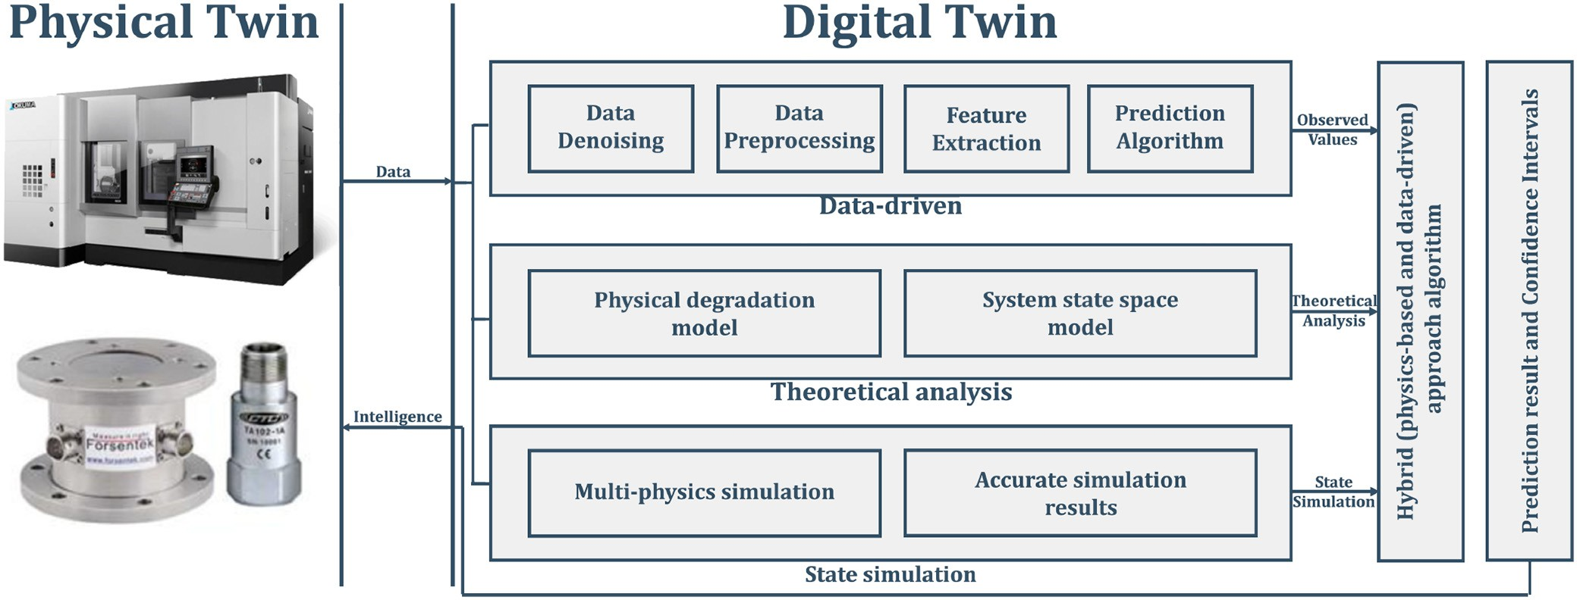

Fig. 10. DT-based PdM scheme using hybrid modeling.

to be fed into the RUL predictor. For remaining life estimation, the authors propose the use of a regression technique called the Support Vector Regression model. Cachada et al. [168] presented a complex and detailed architecture of an intelligent and PdM system that explores the interdependent modules that would constitute a functional block in a PdM frame-work. As such, the paper explains how different approaches are needed for the data acquisition block, depending on the type of input data: automated, semi-automated, or manually introduced by an operator; it also presents an offline data anal-ysis scheme that also relies on the LSTM DL algorithm for prediction of machine state, a dynamic monitoring block that deals with visualisation and early detection of failures, and an intelligent decision support system for maintenance interven-tion that guides the operator through simple instructions and visualisations, in a way that reduces the need for technical knowledge, leaving room for focus on the maintenance task at hand. In this scheme, adjacent blocks communicate with each other in a sequential manner, but as-needed communica-tion between non-adjacent blocks is also allowed for further automated optimisation.
As an overview of the proposed Predictive Maintenance frameworks in the literature up to date, it seems that they adopt the MIMOSA Open System Architecture for Condition-Based Maintenance (OSA-CBM) [169], either completely, or only the main parts of it.
For example, a variation of the OSA-CBM architecture is proposed in [119], where the integration of CPS, DT, and DL extensively rely on each other’s advantages to reduce the need of human intervention usually required in a PdM scheme. In fact, the work suggests a great reliance on DL algo-rithms to completely remove manual feature engineering from the PdM architect’s list of responsibilities. Instead, the intro-duced framework claims DL algorithms can single-handedly manage state detection (through automatic feature extraction), health assessment, RUL estimation, and advisory generation through closed feedback loop connections between different functional layers of the architecture. Such an implementation
would undoubtedly require large amounts of resources in terms of storage space, computational power, and smart equipment. Liang et al. in [170] proposed a layered architecture for a low latency deployment of a Convolutional Neural Network (CNN)—based prognosis system. The proposed scheme con-sists of three layers that share responsibilities effectively, keeping high-speed processing capabilities on the terminal and fog layers, close to the manufacturing equipment, and leav-ing the training of the CNN to the cloud layer. Drawing the line, it seems like the focus has shifted from the development of extremely intricate mathematical health prognosis models, which were tailored to be specific to the equipment, towards data-driven models which predominantly rely on ML and, of course, Big Data. The ability to reliably and quickly trans-port, store, and process huge amounts of data has opened new doors in the world of PdM, immensely facilitating the task. However, that is not to say PdM has become an easy job. The new approach presents other challenges in terms of time, resources, and sets of skills that are required to deliver accurate
predictions of the RUL parameter.
A compromise between the complex, but transparent physics-based models and efficient, but opaque data-driven models, are hybrid models, where researchers have used both approaches simultaneously in order to leverage the advantages from both of them. In this context, Luo et al. [171] have proposed a DT-based PdM scheme that uses physics-based degradation and simulation models to generate theoretical baselines for the machine state, as well as data-centric mod-els that consume real-time streams of data from the sensors installed in the machine. This work has been summarised in Figure 10, and the results of the hybrid model outperformed both physics-driven and data-driven models in predicting the tool wear of a CNC Machine Tool.
In order to achieve satisfying accuracy, PdM schemes that rely solely on Big Data more often than not require massive amounts of historical failure data. For example, Choi et al. [172] proposed a method for predicting the main-tenance needs of an induction furnace with the help of neural

networks. Due to the nature of the ML algorithms used, as well as the data-hungry aspect of PdM, the authors ended up using a data set that consisted of measurements across 24 months. Even then, the conclusion of the article admits that collecting data during faulty scenario was deemed nigh impossible, as running experiments with a failed induction furnace could have been fatally dangerous. As such, the solution to this problem, according to the researchers, was to place focus in their future work on generating and simulating erroneous data, instead of measuring it. In [164], Wang et al. introduced a two-part PdM scheme for the China’s High-Speed Railway equipment using LSTM-RNN. As stated before, any DL approach requires tremendous amounts of data for training. Of course, there is plenty of data that can be generated by a nation-wide business like China’s railway system, however it should be kept in mind that the work’s target equipment, the Traction Power Supply System, is engineered to be sturdy enough to have as few fail-ures as possible per year. As such, gathering historical failure data proved once again to be a prolonged challenge. In this direction, the authors proposed splitting the PdM framework into two: a proactive maintenance system, and a predictive maintenance system. The proactive maintenance system deals with analysing the failure modes of the physical asset to gen-erate new failure data through stochastic modeling. The PdM system is then trained using solely simulated data, and the overall method is then validated using both simulated data and field data. While it turns out that the model performs predictably better on artificial test data rather than on real data, the performance is still very good and it shows promise in the direction of simulation-assisted PdM. Gugulothu et al. in [173] invented an innovative and practical approach to RUL estimation. Their work proves to be robust to noise, sensor inter-dependencies across time, as well as data unavailabil-ity, which are all issues that are very present in various data repositories in the industry. The proposed system uses “embed-dings”, or rather, hidden features extracted by a RNN encoder after it was fed a fixed window-sized signal input from dif-ferent sensors, to extract the Health Index which will then be used to predict the RUL. The remaining life estimation is done by comparing the extracted Health Index with its previously seen values from the training data. The work delivers on its promises, providing a robust RUL estimator that can show good results, as long as enough training data is provided.
It can be noted that many works in the literature are researching ways to compensate for the low amount of his-torical failure data made available by their target monitored physical system. It becomes apparent that the quality of the data and, equally important, the quantity of data are extremely important boxes to check when developing failure prognosis solutions. Over the years, the focus has shifted from model-based PdM, where researchers came to the conclusion that developing a stochastic model for a complex system can be nigh impossible, towards data-driven approaches, where an algorithm can learn from tremendous amounts of histor-ical failure data. And this shift in research direction can be justified. As an example of model-based PdM, where lim-ited amounts of data is not considered a hard constraint, Wang et al. [174] proposed a fault prognosis system for
wind turbine bearing by making use of analytical tools like the wavelet transform (for de-noising and feature extraction), and Bayesian statistics for providing RUL predictions backed by 90% credible intervals, whose accuracy would increase over time. However the goal in I4.0 is to bring PdM to all equipment, including those that are too complex for statistical modeling, which is why the data-driven approach has gained significant traction. And this approach, as the name states, requires large amounts of data that is not always available, especially in old machinery where maintenance records have not been kept, or in equipment whose uptime is so crucial that no run-to-failure scenarios were allowed.

- Digital Twin: Case Studies
This section will take a closer look at DT applications and services by detailing three DT case studies that represent main research directions carried out at the London Digital Twin Research Centre.¹ The subsequent sections will thus sum-marize the research goals, findings, challenges, and future directions for each case study in part.

- A Look at the Tea Industry in India
An important case study that we carried out is from a multi-national tea manufacturing company. It is a semi-automated manufacturing company involving machines and human beings to control them, who bring in several inaccuracies in their processes. The tea bag manufacturing machine operated daily on an average of 20 hours and 2 hours of rest period. Fig. 11 shows the snapshot of the different activities in the conveyor belt of the tea manufacturing company; starting with tea and herbs, dosage, blending, etc. Notably, there is a separate place-holder for filter paper along with its cutting, folding, etc. There are two transport wheels: upper and lower where the oper-ation of thread stitching and the cardboard using needle is being done. This different steps in the process can be clearly understood from the different steps in the process of the tea manufacturing, as shown in Fig. 12. There are several sequen-tial steps and a relation between each step, right from adding tea and herbs, or filter paper to packaging, checking the weight of each box and also investigating rejections and possible reuse of the materials.
There were 6 to 8 downtimes per day over a 24 hour period, each lasting around 15 minutes. The activities during the downtime included: change of product, loading new feed of raw materials, equipment/mechanical failure, misalignments of material feed, effect of new product on machine, etc. Also, an accurate supervision of the facility during night shift is dif-ficult. The tea-bag manufacturing process was studied in detail to detect and keep record on their anomalies, observe any pat-terns, identify prospects for twin modelling and predicting the maintenance needs of the machines. The seven major anoma-lies identified included: (1) Thread knot Anomaly; (2) Outer envelope print not centered; (3) No filter bag in the outer enve-lope; (4) Tag paper print not centered; (5) Outer envelope paper missing; (6) Faulty filter paper tube; (7) Filter paper
1LDTRC website: https://dt.mdx.ac.uk/

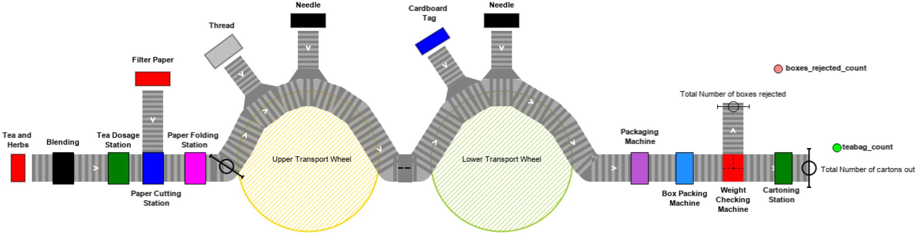

Fig. 11. Conveyor Belt Snapshot of a Tea Manufacturing Plant.
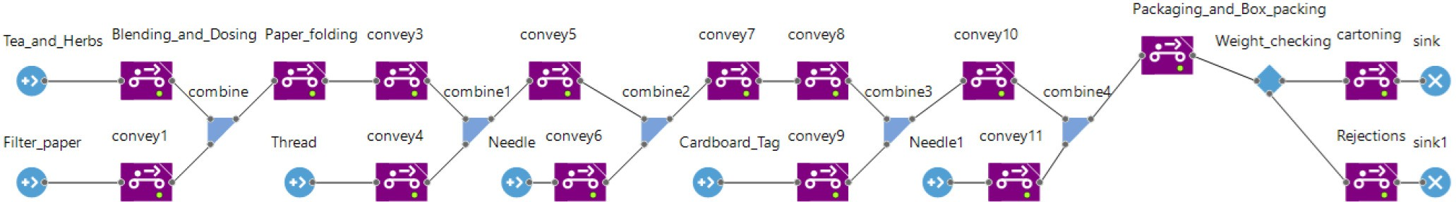

Fig. 12. Steps in the Process of Tea Manufacturing.

slicing. Given the varying nature of the anomalies, they could be detected using multiple step dedicated anomaly detection technique, typically, an N-step approach.
One of the major concerns for a DT is the quality of data being fed. The lack of noise-free data being administered has severe consequences such as sub-standard performance of the twin [15]. This compels the DT to eliminate poten-tial aberrations from the data in order to keep up with its performance. The demand for noise-free data has paved a way for anomaly detection algorithms that would filter spurious instances from datasets. The need for faster and more accurate results obliges the algorithm to have an equilibrium between the two performance parameters: accuracy and execution time. The service of anomaly detection integrated within a virtual twin demonstrates three of the DT’s main characteristic traits enumerated in the definition we provided in Section II, namely: self-adapting, self-monitoring, and self-diagnosing. Through anomaly detection, the DT of the tea factory raises alarms whenever its external environment changes in a way that the DT is not able to recognize, allowing the operator or other pre-defined routines to handle the exceptional anomalies. At the same time, implementing anomaly detection implies the exis-tence of a monitoring mechanism that continuously ingests data and checks for divergent behaviour within it. Lastly, anomalies can be a sign of degradation in some of the physical asset’s systems, so they could trigger pre-defined maintenance pipelines to address these system health issues.
In order to validate this, a two-step anomaly detection tech-nique was developed by Shetve et al. [175] and was evaluated for its data pre-processing capability.
The main drawback of the two-step approach was the dimin-ishing accuracy with increasing outliers. Hence, the two-step approach could be generalized to “N-step approach”. Each step would have its own technique that would be followed by another technique in a sequential manner. The N-step approach has been developed based on following key aspects:
  - Analysis of individual data instances
  - Evaluation of the relationship between neighboring points
  - Identification of the anomalies in dataset by the detection algorithm
  - Evaluation of the performance of N-Step
The techniques selected for each step are as follows: Step 1: DBSCAN (Density-Based Spatial Clustering with Applications in Noise) [176]; Step 2: Isolation Forest; Step 3: LOF (Local Outlier Factor) [177]; Step 4: KNN (K-Nearest Neighbour); Step 5: Hierarchical Classification based methods. The reason for choosing the N-step approach in a particular way is as explained. DBSCAN would provide a very good separation of outliers from the overall data points, removing all false positives. Isolation Forest removes the few left over outliers that are located isolated from one another. Similarly, LOF and other following techniques would remove only the boundary located nodes; thereby removing the True nega-tives and false positives, if any and increasing the success ratio. A careful design of the N-step approach would result in higher accuracy/success ratio with a minimal increase in the
computation time.

- Festo Cyber-Physical Factory
Aside from anomaly detection, another important aspect of DTs in manufacturing, which is also the DT’s original pur-pose, is continuous real-time monitoring of equipment and processes. It is important that smart factory workers have access to always-available digital factory status reports that are intuitive and remotely-accessible. This core feature of DTs enable equipment owners and factory executives to oversee the good functioning of their products and processes. Besides actual operators, the monitoring service can be used by the DT itself in order to maintain awareness, at all times, of its physi-cal asset’s current state and environment. This service enables

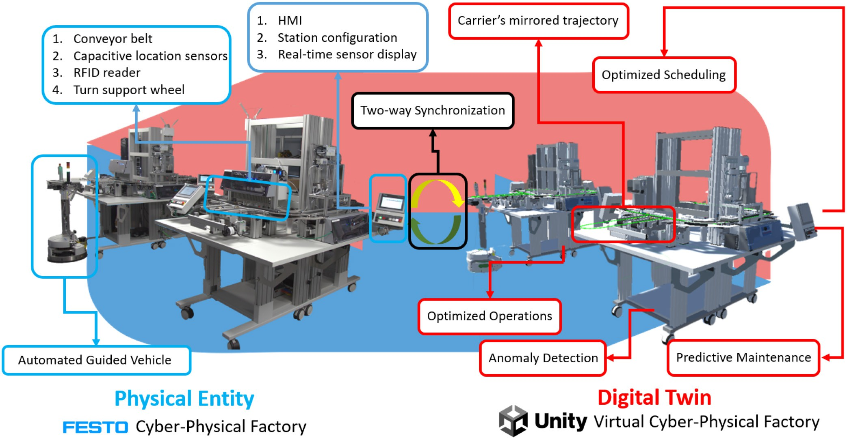

Fig. 13. Digital Twin in I4.0.

a core principle of the DT, detailed in Section II, namely the ability to self-monitor.
On this premise, the work we conducted in [178] developed a DT framework of a real production line, in order to establish a continuous monitoring mechanism for the kine-matics of the factory. The physical twin in question is the Festo Cyber-Physical Factory for I4.0 (CP-Lab) located at Middlesex University, a didactic model of an assembly line for mock mobile phones. The smart factory is composed of six functional stations, each equipped with a Human-Machine Interface, and two transport (or bridge) stations. Figure 13 depicts the physical twin on its left side, and it can be noted that it is composed of two islands, each equipped with four stations. On the first island, the first station is tasked with placing the back plastic cover of the mock mobile phone onto the carrier, which is then carried to the next islands via a conveyor belt. The second station is the manual station, where a human operator will place a Printed Circuit Board (PCB) onto the back cover. The third station visually inspects the product automatically, to verify that the PCB that was previously added corresponds to the correct order specifica-tions. Lastly, a bridge station takes the carrier and passes it on to an Automated Guided Vehicle (AGV) that transports it towards the second island with its next four stations. The second island is also equipped with a bridge station that inter-cepts the AGV and sends the carrier to the island’s second station, which places another plastic cover on top of the prod-uct. The next station applies a pre-defined pressure onto the product to seal the two plastic covers. Finally, the last com-ponent of the assembly line is the furnace, where the product is heated up to a user-defined temperature to complete the order.
The kinematic model of this assembly line, which initially only mirrored one station of the CP-Lab, was later migrated to the Unity game engine, where the whole structure and motion of the smart factory was modeled (right side of Figure 13). In addition, the virtual model captures streams of sensor data flowing from the CP-Lab via the TCP protocol. This led to the development of a DT-based PdM framework that includes a monitoring dashboard for the machine’s sensors (temper-ature and power data) [179]. The framework makes use of real data coming from the CP-Lab, as well as configuration data stored on the DT, to better position the working regime, identify working stations, and assess the health of individual stations via data pertaining to the whole island. More specif-ically, the framework targets the health of the furnace station of the second island. Being that it is equipped with a power-ful heating element, the malfunctioning of this station could potentially lead to a fire hazard, so it stands to reason that guaranteeing its good health is a necessity. For this reason, the furnace is also equipped with a “Safety Shutdown” mech-anism, that will completely halt operations if the temperature inside its chamber surpasses 80◦C, however, this system is
also not infallible. As such, the framework captures tempera-
ture data from inside the furnace, as well as the power data pertaining to the whole second island, to predict if, or when, the Safety Shutdown mechanism will be triggered, in order to proactively prevent it. The DT provides the configuration data of the heating station (i.e., its real-time state) to help the framework extract the furnace’s power consumption from the second island’s power measurements. As such, in case the temperature sensor or element inside the heating chamber are faulty, the normal behaviour of the station can still be veri-fied via its power data. The DT of the CP-Lab can increase

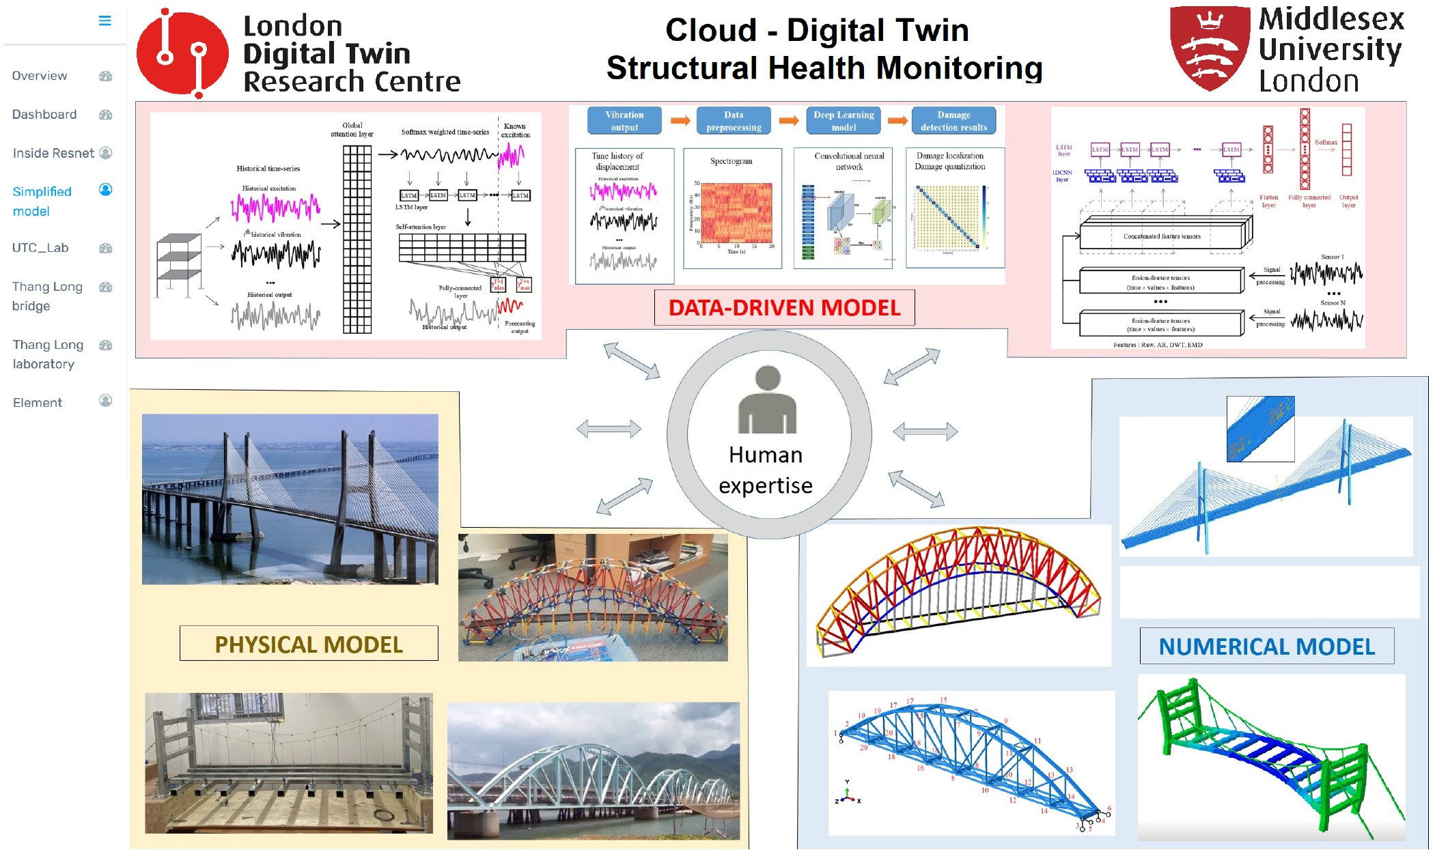

Fig. 14. Cloud Digital Twin Structural Health Monitoring Web application.

productivity by preventing the unnecessary or anomalous trig-gering of the Safety Shutdown mechanism, as well as promote safety by predicting when the temperature inside the heating chamber of the Tunnel Furnace Station reaches critical levels.
- Structural Health Monitoring for Vietnam bridges
In this section, the Digital Twin framework for SHM developed at London Digital Twin Research Centre, dubbed cDTSHM is presented, including its main components, case studies, and its application to bridges, mainly in Vietnam. The cDTSHM consists of four components: the real structures equipped with sensors along their body providing data related to their operational services, a fog layer with local compu-tational servers preprocessing measured data, a cloud layer involving data storage services, and data analytic components leveraging both mathematical models and machine learning-based model, and a Web application visualizing the data and computed results. The cDTSHM is developed with the help of the AWS cloud services; most of the programs are written in Python, the ML-based model is implemented using the DL library Pytorch, and the main input data for the framework are the vibration data from accelerometer sensors. Fig. 14 depicts the interface of the cDTSHM, including case studies carried out.
The first case study to demonstrate the applicability of the framework is a toy model of the Sydney Harbour bridge built by using K’nex interlocking plastic rods. Next, one manu-ally excites the model by hand-shaking, where its vibration is recorded by using a set of accelerometer sensors MPU-6050
uniformly distributed across the model. The SHM database was empirically generated by hand-shaking the model; then vibration data were collected through an array of accelerom-eter sensors MPU-6050 and a microcontroller board Arduino Uno. The damaged states of the model were introduced by randomly removing one or two truss rods. After that, two data analytic algorithms, including a lite mathematical model and a ML-based model are developed to detect the structure status. Furthermore, the latter could spatially localize the damage’s location and quantize the damage severity.
The second case study used to validate the correctness of the framework is a simplified laboratory model of a stayed-cable bridge whose physical and numerical models are shown in the corner of Fig. 14. The SHM procedure is realized similarly to the first example, but the experiment data, including excita-tion, vibration data, structure’s deformation are controlled and measured more rigorously. The model is excited by introduc-ing an impulse force of very short duration through an impact hammer; the structure’s status is then assessed based on the loss level of prestressing strands which can be manually mod-ified by alternating the anchor bolts tightness. As a result, the sDTSHM can provide highly accurate SHM results with much less CPU time while bypassing the cumbersome preprocessing modal analysis as in the conventional structural identification methods.
For the third case study, the performance of the SHM frame-work is tested with real data collected from the Z24 bridge in Switzerland [180]. For such a real structure, using a lite math-ematical model or shallow ML cannot provide reliable SHM

results. Thus, a highly modular architecture has been devised, allowing switching different DL algorithms and combining data from different sensors in a straightforward way [181]. The results demonstrate that the data analytic component of the cDTSHM outperforms competing methods with a structural damage detection result of 90.1% with low time complexity and budget memory storage.
Afterwards, the cDTSHM framework is applied to the Nam O railway bridge located in central Vietnam. The bridge is
60 years old and constantly undergoes unfavorable factors involving the corrosive maritime environment, dynamic and heavy train loadings, etc. From the structural perspective, the structure’s mode shapes and their high-order derivatives are sensitive to damages; therefore, a knowledge-enhanced deep 1D-CNN has been developed for automatically extract-ing modal characteristics from raw vibration data to accurately detect and quantify connection stiffness reductions. The real-ization steps and implementation details can be found in [182]. The results show that the framework could achieve accuracy up to 95% even with minor damage (5% of stiffness reduc-tion) with faster convergence speed and more stable results than counterparts, including the Multi-Layer Perceptron and other DL architectures.
The four case studies illustrated in this section demon-strate that the enabling technologies supporting a DT will vary greatly, depending on the DT’s use-case, as also mentioned in our definition, provided in Section II. Additionally, the cDT-SHM framework has been developed to exhibit self-diagnosing and self-monitoring capabilities within several case studies of bridges.

- Lessons Learned, Research Challenges and Future Directions
The previous sections provided a comprehensive view of the DT, commencing with its definition, market poten-tial, enabling technologies, frameworks and applications, and, finally, three case studies. Throughout the literature surveyed in this manuscript, as well as our own experience in develop-ing DTs, we have learned important lessons and encountered significant challenges that will contour future directions for us and the research community. This section will delve into the most significant of these concepts, detailing the obstacles that the DT needs to overcome in order to realize its potential.

- Investment Costs
As mentioned in Section III, businesses still remain reluctant to implement the DT because of its envisioned development costs and difficult-to-quantify ROI. As a matter of fact, it is rather challenging to put a price on the DT because of its multi-disciplinary nature and use-case-specific particularities. Additionally, the DT is rarely a product that generates direct profit, since its core philosophy focuses primarily on saving costs. With the exception of DT solution providers and the healthcare industry, where the DT can indeed be a source of revenue, other entrepreneurs will need detailed and long-term plans of investment that emphasize the merits of DT development before diving into such expenditures.
One important aspect that must be factored into the costs when planning for DTs, is the ongoing maintenance require-ments, such as: software updates that affect the DT, changes to the physical asset, etc. Considering the total life cycle of the DTs, one could anticipate that the maintenance and man-agement cost might represent the largest proportion of the investment costs.

- Social and Ethical Challenges
Digital Twin technology and applications are experienc-ing a shift from engineering/physics based domains, where closed equations are an appropriate modelling abstraction, to one where the problem domain is socio-technical, lead-ing to the notion of Socio-Technical Digital Twins (STDT). Such a problem domain utilises systems that comprise com-plex interaction between humans, machines and the work environment [183]. This class of system is characterised by heterogeneous networked agents, adaptive and goal oriented with respect to the environment and joint optimisation and evolution of both technical and social systems [184]. These properties are also those that are characterised by agent based systems and make such technologies ideal for representation of STDTs despite computational cost [184], [185]. Hence, STDTs generate new and different research challenges.
DTs of phenomena that include human interactions and behaviours acquire complexity simply due to the involvement of multiple disciplines. For example, DT models of cities for monitoring pandemic behaviour have included social geogra-phers, economists, medical practitioners as well as computer scientists. Arriving at a shared understanding, common lan-guage and a way of working demands new methodological approaches as well as intuitive access to underpinning theory from different disciplines [186].
Moving away from closed equations to systems that model emergent behaviour presents expected validation challenges. Recognising that a STDT has purpose beyond prediction such as explanation is the first response [187]. STDTs can be used for discovering new questions, demonstrating trade-offs or experimentation with prevailing theories that lack empiri-cal understanding. Hence they represent a move away from closed form analytical models. Models are a form of the-ory building [188] and as such they can only be invalidated so a more useful target is a form of accredited or accepted model based on standardised criteria and metrics [189]. As STDTs become more established, policy oriented domain-specific practice could lead to libraries of accepted models, encoding existing knowledge, that do not need to change and are much less volatile. Given the emergent properties of STDTs, such models need to be defined at both micro, meso and macro levels. Building libraries of STDT models is reminiscent of component based development practice and its inherent challenges [190].
Validation of a model for STDT is closely related to abstrac-tion concerns and in particular the challenges that arise from establishing an appropriate framing structure. The complex-ity, multi-level and range of modelling required to represent a socio-technical problem domain within a DT require choices

to be made in determining the scope and detail of the envi-ronment to be modelled. This choice we can refer to it as a conceptual problem frame. For example, Barat et al. [186] in their city DT of Pune, for modelling the COVID-19 pan-demic, observe that existing agent based systems for pandemic modelling do not show sufficient granularity of types of peo-ple and their movements within the city, raising concerns of model completeness.
Perhaps the most striking challenge that needs to be addressed is that arising from STDTs that include ML or other algorithmic decision making. Ethical concerns come to the fore when (1) conclusions drawn from inference are probable and therefore an epistemic limitation; (2) traceabil-ity between the input data and conclusion is not accessible and open to critique; (2) conclusions are dependent upon the quality of data; or (4) the actions based on conclusions are dis-criminatory even if well-founded [191]. Underpinnning these epistemically-based ethical issues is the encoding of value systems such as privacy, transparency, security and so on. Understanding value sensitive concerns and related approaches that explore more fundamentally the nature of social require-ments and (unintended social impacts) of software remains an ongoing project in software engineering [192] and requires study in the context of STDTs.

- Fidelity and Rate of Synchronization
A common misconception about the DT is that the vir-tual twin should reflect the physical twin in its entirety, and that it should gather and process all of its data in almost real-time. However, these feats are not currently feasible, and certainly not always necessary. As specified in our definition of the DT, provided in Section II, the virtual representation’s fidelity and rate of synchronization are specific to the DT’s use-cases. For instance, for ambitious, nation-wide project like the U.S. Air Force’s DT for weapon system development, the required fidelity and responsiveness might impose prohibitive costs [193]. On the other hand, for the purposes of traffic relief, a DT that stores the coordinates and synchronization rates of traffic lights, as well as the real-time traffic density, might arguably perform almost as well as a DT that completely 3D models the city’s infrastructure. As such, the DT’s granularity and twinning rate requirements can be more, or less, lenient, depending on its applications. The more stringent demands for real-time, granular mirroring could be encountered in the healthcare industry, for scenarios where the DT is used to facilitate remote surgery.

- Standardisation Efforts
One of the most important features that could acceler-ate the adoption of DTs within various industries is their modularity. This could enable the rapid reproduction of DT processes and their components. However, this dynamic envi-ronment could become very complex, with different digital twins custom built for different purposes, specific equipment type, specific manufacturers, etc., these represent factors that could inhibit the adoption and implementation of DTs across
multiple industries. These complexities could be eliminated through standardisation.
Recently, one of the subcommittees (SC 41)² of the Joint International Organization for Standardization (ISO) and International Electrotechnical Commission (IEC) Technical Committee (JTC 1)³ has widened its scope and terms of refer-ences to include DT, looking now into standardization in the area of IoT and DTs, including their related technologies.
The ISO 23247-1⁴ standard for DT framework for man-ufacturing is currently under development. The first part of the standard provides general principles and defines the requirements for developing DTs in manufacturing.
Similarly, the National Institute of Standards and Technology (NIST) in an attempt to standardize the DT technology, have released a draft NISTIR 8356 [194] cov-ering the definition, common low-level operations, usage scenarios, and use-cases examples.
Another initiative that has as a primary objective to influ-ence the requirements for DT standards is the Digital Twin Consortium.⁵ The consortium consists of members from indus-try, government, and academia that form a global ecosystem aiming to accelerate the development, adoption, interoperabil-ity, and security of DTs.
One proposed solution by Harper et al. [195] could be to define a set of standardised Application Process Interfaces (APIs) that could evolve over time. The advantage of this approach is that different DTs could be developed using differ-ent software and processes as long as they support the defined set of APIs.
Microsoft developed the Digital Twin Definition Language⁶ (DTDL) that is used in their commercial services, such as IoT Hub, IoT Central and Azure Digital Twins. However, DTDL does not resource discovery and access and deals with resource description only.
Consequently, the current lack of standardised approaches when modelling digital twins open up new challenges when dealing with their interoperability in order to maximize the interconnectivity.

- Data Ownership and Governance
Apart from standardisation, another closely related chal-lenge is the data ownership and governance, that brings a new question, specifically: Who owns the DT information? One can anticipate that with the advancements in technologies, the industry is moving towards a connected data ecosystem of DTs with potential different owners of the physical assets as well as the DTs. Additionally, the potential existence of an ecosys-tem of DTs implies the need for a shared communication framework for standardized data exchange between multiple heterogeneous data sources. This scenario brings technical, financial and legal aspects challenges that need to be clarified.

2SC 41: https://bit.ly/3tf0hSM.
3JTC 1: https://jtc1info.org/.
4ISO 23247-1 Digital Twin Framework for Manufacturing: https://www. iso.org/standard/75066.html.
5Digital Twin Consortium: https://www.digitaltwinconsortium.org.
6Digital Twin Definition Language: https://bit.ly/3jJ3EOV.

One solution would be to adopt the Industrial Data Space (IDS)⁷ concept that has been introduced in [196] to cater for all these issues within the I4.0 framework. The IDS concept represents a virtual data space that enforces data ownership within a distributed environment, based on open standards and existing technologies as well as common governance models for data economy. As DTs are seen as part of I4.0, the IDS model could be the answer for DTs data ownership and governance. In parallel, an effort for constructing an Information Management Framework (IMF) for the National Digital Twin is carried out in [197], where the goal is to create a common national information resource that can sustain a country-wide DT.

- Data Security
There are two ways to approach the discussion on security issues in DTs. The first one addresses the security of the DT itself, starting from the physical servers that host the DTs up until the safety and integrity of the software and data com-munication links that animate the DT. The second approach is about how the DT itself can provide security to its real twin, as an additional valuable offering. This section will touch on both of these aspects of security within DTs.
One of the central components of a DT is the communica-tion medium that enables the symbiotic relationship between the physical and virtual twins. This link effectively transports all the data between the two entities, so it stands to reason that it needs to guarantee impeccable data security. Every time data flows to, and from, the real twin, or in-between the servers hosting the DT itself, the risk of losing impor-tant information is high, which calls for increased attention to preserving data integrity [198]. This communication medium becomes a potential area of weakness in front of data corrup-tion and theft, and it can create disturbances for businesses. As such, data security principles, like privacy, authentication, integrity, and traceability, need to be taken into account during DT development. Some important measures that provide secu-rity features are data encryption, access privileges, source code automated scanning, penetration testing, and routine check-ups [199]. Emerging approaches to deal with these issues include using blockchain technologies to ensure data privacy in the communication between DT systems-of-systems [94]. Yaqoob et al. [200] conducted an extensive research on how blockchain has been integrated in the DTs across literature to also ensure trust and transparency in various use cases.
Given that the DT is still an emerging technology, the related literature still lacks a consensus on its security require-ments. As we have discovered throughout this research work, the use case and services envisioned for the DT can dictate the architecture of the virtual twin. According to Gehrmann and Gunnarsson in [201], security measures should also be at the forefront of the DT architects’ minds since they can have a significant impact on the final DT model’s structure as well. The authors also introduced the idea of using the DT as an enabler of security in the communication between the physi-cal twin and other cloud-based services, of which DTs might make use. In their work, all external communication with the
7Industrial Data Space: https://internationaldataspaces.org.
physical twin would be carried out exclusively via the virtual model, through a synchronization gateway that filters all traf-fic to the real twin, effectively isolating it from bad agents. A similar approach was taken in [202], where the authors proposed using the DT to filter out incoming commands to a smart inverter and ensure that only the non-malicious ones are carried out.
- Artificial General Intelligence, Beyond Human Performance
In Section II of this manuscript, we have described the DT as a self-adapting, self-regulating, self-monitoring, and self-diagnosing system-of-systems, a definition which places it under the span of another, broader category of human ambi-tions: Artificial Intelligence. In fact, the idea of self-improving artificial systems was part of the original proposal made by McCarthy et al. in 1955 for the Darthmouth Summer Research Project on AI, a project which is also sometimes dubbed as the birthplace of AI [203]. Since then, significant progress has been carried out towards realizing the objectives laid out in said pro-posal, and the term “AI” has now become so popular that some voices have raised concerns about the implications of integrating AI into our society [204]. However, as Shevlin et al. emphasize in [205], there is an important distinction to be made between the original meaning assigned to AI by McCarthy et al. in 1955, and AI as it is understood and marketed today. McCarthy’s proposal identified AI as a machine that behaves “in ways that would be called intelligent if a human were so behaving”, whereas nowadays, AI is sometimes used to refer to systems that reach or surpass human performance in specific tasks [206], [207]. The former interpretation corresponds to what is today understood as Artificial General Intelligence (AGI), while the latter is an appropriate example of Artificial Narrow Intelligence (ANI) [205].
However, although there is a great overlap between the DT and AGI, there are some differences that stand out and can make the DT an even more challenging task than AGI. First, the versatility of the DT paradigm across industries implies that it will, by definition, have a specialized kind of intelligence that cannot be generalized to other domains, but trains and excels in every possible task that pertains to the physical twin’s use cases, including hypothetical scenar-ios. In order for the DT to become truly self-evolving, just like humans and animals are, it needs to be able to imple-ment a level of creativity that can make maximal use of its physical twin’s unique features (i.e., learn to become as resourceful with its physical structure as an animal is with its body). This implies that, just like there is a need for stan-dardized benchmarks for validating human AGI, or animal intelligence-mimicking AGI [205], there is also a requirement for performance measures and benchmarks that can accurately evaluate the DT for each industry and application. Validation metrics aside, while current AI systems can definitely learn to perform tasks even beyond human-level performance, they also lack comprehension, and therefore cannot offer transparency into their “reasoning” [208]. This lack of transparency invokes skepticism, and can even impede development of DTs or AIs due to lack of trust.

- Conclusion
This paper took an in-depth look at the existing and expand-ing Digital Twin-related literature, and we drew some lessons that will help the researchers in this field consolidate their understanding of the DT and choose future directions that need further development. In Section II, we took a look at the variety of DT definitions that the papers reviewed in this manuscript provided and we clustered them together according to their similarity; then, we introduced a new, comprehensive definition for the DT that covers important aspects that the others might have missed. In Section III, we evaluated the current level of adoption of the DT in the industry, and how this paradigm is currently valued by various leading busi-nesses in this field. Section IV then dove into the technical aspects of the DT, namely its enabling technologies, and how they are being used to support the DT in delivering business value across various industries. Consequently, in Section V, we described how the previously presented technologies help the DT in providing a handful of services, ranging from smart manufacturing to new generation communication technologies. Section VI offered a closer look at three DT case studies in order to present how the technology can be leveraged and what requirements and limitations appear, based on the use case. Finally, Section VII summarized the lessons we have learned throughout this review, in order to point out interesting new challenges to be addressed in the research community.
Overall, the DT finds itself accelerating in full force towards I4.0, and its endless perceived potential makes it a central and evermore popular player in the race. Its enabling technolo-gies are continuously evolving, and each step towards their improvement brings us closer to making true DTs a reality. As the DT attracts research interest, the number of attempts at developing it contour some common and persisting obstacles. In the era of AI, the focus falls on the data, and the DT finds itself in the middle of an information loop: it needs to be fed carefully considered data to power its complex ML algorithms, and then it further allows a better understanding of that data via its interactive and predictive feats. With some challenging puzzles in the way, the DT is steadily heading towards the automation of industrial processes.

References
- L. Laura, O. Clayton, S. Jeremy, and S. Kate, How COVID-19 Has Pushed Companies Over the Technology Tipping Point and Transformed Business Forever, McKinsey Company, New York, NY, USA, 2020.
- S. Blackburn, L. LaBerge, C. O’Toole, and J. Schneider. “Digital Strategy in a Time of Crisis.” Apr. 2020. [Online]. Available: https://www.mckinsey.com/capabilities/mckinsey-digital/our-insights/ digital-strategy-in-a-time-of-crisis
- Cisco. “Cisco Annual Internet Report (2018–2023) White Paper.” 2020. Accessed: Sep. 12, 2021. [Online]. Available: https://www.cisco.com/ c/en/us/solutions/collateral/executive-perspectives/Annu.-internet-Rep./ whitepaper-c11-741490.html
- M. Grieves and J. Vickers, “Digital twin: Mitigating unpre-dictable, undesirable emergent behavior in complex systems,” in Transdisciplinary Perspectives on Complex Systems: New Findings and Approaches, F.-J. Kahlen, S. Flumerfelt, and A. Alves, Eds. Cham, Switzerland: Springer Int., 2017, pp. 85–113. [Online]. Available: https://doi.org/10.1007/978-3-319-38756-7_4

- M. E. Rose and J. R. Kitchin, “Pybliometrics: Scriptable bibliometrics using a python interface to Scopus,” SoftwareX, vol. 10, Jul.–Dec. 2019, Art. no. 100263.
- B. R. Barricelli, E. Casiraghi, and D. Fogli, “A survey on digital twin: Definitions, characteristics, applications, and design implications,” IEEE Access, vol. 7, pp. 167653–167671, 2019.
- R. Minerva, G. M. Lee, and N. Crespi, “Digital twin in the IoT context: A survey on technical features, scenarios, and architectural models,” Proc. IEEE, vol. 108, no. 10, pp. 1785–1824, Oct. 2020.
- A. Löcklin, M. Müller, T. Jung, N. Jazdi, D. White, and M. Weyrich, “Digital twin for verification and validation of industrial automation systems—A survey,” in Proc. 25th IEEE Int. Conf. Emerg. Technol. Factory Autom. (ETFA), vol. 1, 2020, pp. 851–858.
- F. Biesinger, B. Kraß, and M. Weyrich, “A survey on the necessity for a digital twin of production in the automotive industry,” in Proc. IEEE 23rd Int. Conf. Mechatronics Technol. (ICMT), 2019, pp. 1–8.
- Y. He, J. Guo, and X. Zheng, “From surveillance to digital twin: Challenges and recent advances of signal processing for Industrial Internet of Things,” IEEE Signal Process. Mag., vol. 35, no. 5,
pp. 120–129, Sep. 2018.
- F. Pires, A. Cachada, J. Barbosa, A. P. Moreira, and P. Leitão, “Digital twin in industry 4.0: Technologies, applications and challenges,” in Proc. IEEE 17th Int. Conf. Ind. Inf. (INDIN), vol. 1, 2019, pp. 721–726.
- A. Rasheed, O. San, and T. Kvamsdal, “Digital twin: Values, chal-lenges and enablers from a modeling perspective,” IEEE Access, vol. 8,
pp. 21980–22012, 2020.
- F. Tao, H. Zhang, A. Liu, and A. Y. C. Nee, “Digital twin in indus-try: State-of-the-art,” IEEE Trans. Ind. Informat., vol. 15, no. 4,
pp. 2405–2415, Apr. 2019.
- Z. Huang, Y. Shen, J. Li, M. Fey, and C. Brecher, “A survey on AI-driven digital twins in industry 4.0: Smart manufacturing and advanced robotics,” Sensors, vol. 21, no. 19, p. 6340, 2021. [Online]. Available: https://www.mdpi.com/1424-8220/21/19/6340
- A. Fuller, Z. Fan, C. Day, and C. Barlow, “Digital twin: Enabling technologies, challenges and open research,” IEEE Access, vol. 8,
pp. 108952–108971, 2020.
- NASA. “Apollo expeditions to the moon: Chapter 13.” Accessed: Jun. 22, 2021. [Online]. Available: https://www.hq.nasa.gov/office/pao/ History/SP-350/ch-13-1.html
- K. Dröder, P. Bobka, T. Germann, F. Gabriel, and F. Dietrich, “A machine learning-enhanced digital twin approach for human–robot-collaboration,” Procedia CIRP, vol. 76, pp. 187–192, Jan. 2018, doi: 10.1016/j.procir.2018.02.010.
- M. Xia, H. Shao, D. Williams, S. Lu, L. Shu, and C. W. de Silva, “Intelligent fault diagnosis of machinery using digital twin-assisted deep transfer learning,” Rel. Eng. Syst. Safety, vol. 215, Nov. 2021, Art. no. 107938.
- Q. Qi, D. Zhao, T. W. Liao, and F. Tao, “Modeling of cyber-physical systems and digital twin based on edge computing, fog computing and cloud computing towards smart manufacturing,” in Proc. Int. Manuf. Sci. Eng. Conf., vol. 51357, Jun. 2018, Art. no. V001T05A018.
- V. Souza, R. Cruz, W. Silva, S. Lins, and V. Lucena, “A digital twin architecture based on the Industrial Internet of Things technologies,” in Proc. IEEE Int. Conf. Consum. Electron. (ICCE), 2019, pp. 1–2.
- J. Leng, H. Zhang, D. Yan, Q. Liu, X. Chen, and D. Zhang, “Digital twin-driven manufacturing cyber-physical system for parallel con-trolling of smart workshop,” J. Ambient Intell. Humanized Comput., vol. 10, no. 3, pp. 1155–1166, 2019.
- S. Aheleroff, X. Xu, R. Y. Zhong, and Y. Lu, “Digital twin as a service (DTaaS) in industry 4.0: An architecture reference model,” Adv. Eng. Inf., vol. 47, Jan. 2021, Art. no. 101225.
- K. Xia et al., “A digital twin to train deep reinforcement learning agent for smart manufacturing plants: Environment, interfaces and intelligence,” J. Manuf. Syst., vol. 58, pp. 210–230, Jan. 2021.
- P. Wang and M. Luo, “A digital twin-based big data virtual and real fusion learning reference framework supported by industrial Internet towards smart manufacturing,” J. Manuf. Syst., vol. 58, pp. 16–32, Jan. 2021.
- W. Xu, J. Cui, L. Li, B. Yao, S. Tian, and Z. Zhou, “Digital twin-based industrial cloud robotics: Framework, control approach and implementation,” J. Manuf. Syst., vol. 58, pp. 196–209, Jan. 2021.
- Y. Liu et al., “A novel cloud-based framework for the elderly Healthcare services using digital twin,” IEEE Access, vol. 7,
pp. 49088–49101, 2019.

- C. Liu, L. Le Roux, C. Körner, O. Tabaste, F. Lacan, and S. Bigot, “Digital twin-enabled collaborative data management for metal addi-tive manufacturing systems,” J. Manuf. Syst., vol. 62, pp. 857–874, Jan. 2022.
- Z. Zhao, L. Shen, C. Yang, W. Wu, M. Zhang, and G. Q. Huang, “IoT and digital twin enabled smart tracking for safety management,” Comput. Oper. Res., vol. 128, Apr. 2021, Art. no. 105183.
- C. Liu, P. Jiang, and W. Jiang, “Web-based digital twin modeling and remote control of cyber-physical production systems,” Robot. Comput. Integr. Manuf., vol. 64, Aug. 2020, Art. no. 101956.
- X. He, Q. Ai, R. C. Qiu, and D. Zhang, “Preliminary exploration on digital twin for power systems: Challenges, framework, and applica-tions,” 2019, arXiv:1909.06977.
- Y. Xu, Y. Sun, X. Liu, and Y. Zheng, “A digital-twin-assisted fault diagnosis using deep transfer learning,” IEEE Access, vol. 7,
pp. 19990–19999, 2019.
- W. Hofmann and F. Branding, “Implementation of an IoT-and cloud-based digital twin for real-time decision support in port operations,” IFAC PapersOnLine, vol. 52, no. 13, pp. 2104–2109, 2019.
- L. López-Estrada, M. Fajardo-Pruna, S. Gualoto-Condor, J. Ríos, and
A. Vizán, “Creation of a micro cutting machine tool digital-twin using a cloud-based model-based PLM platform: First results,” Procedia Manuf., vol. 41, pp. 137–144, Jan. 2019.
- Y. Pan, T. Qu, N. Wu, M. Khalgui, and G. Huang, “Digital twin based real-time production logistics synchronization system in a multi-level computing architecture,” J. Manuf. Syst., vol. 58, pp. 246–260, Jan. 2021.
- E. P. Hinchy, N. P. O’Dowd, and C. T. McCarthy, “Using open-source microcontrollers to enable digital twin communication for smart manufacturing,” Procedia Manuf., vol. 38, pp. 1213–1219, Jan. 2019.
- F. Tao, Q. Qi, L. Wang, and A. Nee, “Digital twins and cyber–physical systems toward smart manufacturing and industry 4.0: Correlation and comparison,” Engineering, vol. 5, no. 4, pp. 653–661, 2019.
- M. Borth, J. Verriet, and G. Muller, “Digital twin strategies for SoS 4 challenges and 4 architecture setups for digital twins of SoS,” in Proc. IEEE 14th Annu. Conf. Syst. Syst. Eng. (SoSE), 2019, pp. 164–169.
- E. Negri, S. Berardi, L. Fumagalli, and M. Macchi, “MES-integrated digital twin frameworks,” J. Manuf. Syst., vol. 56, pp. 58–71, Jul. 2020.
- R. Dong, C. She, W. Hardjawana, Y. Li, and B. Vucetic, “Deep learn-ing for hybrid 5G services in mobile edge computing systems: Learn from a digital twin,” IEEE Trans. Wireless Commun., vol. 18, no. 10,
pp. 4692–4707, Oct. 2019.
- T. Zohdi, “A machine-learning framework for rapid adaptive digital-twin based fire-propagation simulation in complex environ-ments,” Comput. Methods Appl. Mech. Eng., vol. 363, May 2020, Art. no. 112907.
- T. Ritto and F. Rochinha, “Digital twin, physics-based model, and machine learning applied to damage detection in structures,” Mech. Syst. Signal Process., vol. 155, Jun. 2021, Art. no. 107614.
- S. Chakraborty and S. Adhikari, “Machine learning based digital twin for dynamical systems with multiple time-scales,” Comput. Struct., vol. 243, Jan. 2021, Art. no. 106410.
- M. A. Ali, Q. Guan, R. Umer, W. J. Cantwell, and T. Zhang, “Deep learning based semantic segmentation of µCT images for creating dig-ital material twins of fibrous reinforcements,” Composites A Appl. Sci. Manuf., vol. 139, Mar. 2020, Art. no. 106131.
- B. Maschler, D. Braun, N. Jazdi, and M. Weyrich, “Transfer learning as an enabler of the intelligent digital twin,” Procedia CIRP, vol. 100,
pp. 127–132, Jan. 2021.
- Z. Wang et al., “A digital twin paradigm: Vehicle-to-cloud based advanced driver assistance systems,” in Proc. IEEE 91st Veh. Technol. Conf. (VTC-Spring), 2020, pp. 1–6.
- P. K. Rajesh, N. Manikandan, C. S. Ramshankar, T. Vishwanathan, and C. Sathishkumar, “Digital twin of an automotive brake pad for predictive maintenance,” Procedia Comput. Sci., vol. 165, pp. 18–24, Jan. 2019.
- R. Revetria, F. Tonelli, L. Damiani, M. Demartini, F. Bisio, and
N. Peruzzo, “A real-time mechanical structures monitoring system based on digital twin, IoT and augmented reality,” in Proc. IEEE Spring Simulat. Conf. (SpringSim), 2019, pp. 1–10.
- G. White, A. Zink, L. Codecá, and S. Clarke, “A digital twin smart city for citizen feedback,” Cities, vol. 110, Mar. 2021, Art. no. 103064.
- A. Burger, C. Cichiwskyj, S. Schmeißer, and G. Schiele, “The elastic Internet of Things—A platform for self-integrating and self-adaptive IoT-systems with support for embedded adaptive hardware,” Future Gener. Comput. Syst., vol. 113, pp. 607–619, Dec. 2020.
- E. Y. Song, M. Burns, A. Pandey, and T. Roth, “IEEE 1451 smart sensor digital twin federation for IoT/CPS research,” in Proc. IEEE Sensors Appl. Symp. (SAS), 2019, pp. 1–6.
- S. M. Bazaz, M. Lohtander, and J. Varis, “5-Dimensional defini-tion for a manufacturing digital twin,” Procedia Manuf., vol. 38,
pp. 1705–1712, Jan. 2019.
- E. Negri, L. Fumagalli, C. Cimino, and M. Macchi, “FMU-supported simulation for CPS digital twin,” Procedia Manuf., vol. 28,
pp. 201–206, Jan. 2019.
- E. Negri, H. D. Ardakani, L. Cattaneo, J. Singh, M. Macchi, and J. Lee, “A digital twin-based scheduling framework including equipment health index and genetic algorithms,” IFAC PapersOnLine, vol. 52, no. 10, pp. 43–48, 2019.
- M. Glatt, C. Sinnwell, L. Yi, S. Donohoe, B. Ravani, and J. C. Aurich, “Modeling and implementation of a digital twin of material flows based on physics simulation,” J. Manuf. Syst., vol. 58, pp. 231–245, Jan. 2021.
- Q. Min, Y. Lu, Z. Liu, C. Su, and B. Wang, “Machine learning based digital twin framework for production optimization in petrochemical industry,” Int. J. Inf. Manag., vol. 49, pp. 502–519, Dec. 2019.
- H. Laaki, Y. Miche, and K. Tammi, “Prototyping a digital twin for real time remote control over mobile networks: Application of remote surgery,” IEEE Access, vol. 7, pp. 20325–20336, 2019.
- D. Guo, R. Y. Zhong, P. Lin, Z. Lyu, Y. Rong, and G. Q. Huang, “Digital twin-enabled graduation intelligent manufacturing system for fixed-position assembly islands,” Robot. Comput. Integr. Manuf., vol. 63, Jun. 2020, Art. no. 101917.
- M. Matulis and C. Harvey, “A robot arm digital twin utilising reinforce-ment learning,” Comput. Graph., vol. 95, pp. 106–114, Apr. 2021.
- P. Zheng and A. S. Sivabalan, “A generic tri-model-based approach for product-level digital twin development in a smart manufacturing environment,” Robot. Comput. Integr. Manuf., vol. 64, Aug. 2020, Art. no. 101958.
- “What is a digital twin?” IBM. Accessed: Jan. 26, 2022. [Online].
Available: https://www.ibm.com/uk-en/topics/what-is-a-digital-twin
- A. Mehra. “Digital Twin Market Worth $48.2 Billion by 2026.” Accessed: Jun. 22, 2021. [Online]. Available: https://www. marketsandmarkets.com/PressReleases/digital-twin.asp
- IBM. “Hong Kong Applied Science and Technology Research Institute Company Limited.” Accessed: Jun. 22, 2021. [Online]. Available: https://www.ibm.com/case-studies/hong-kong-astri-engineering-rhapsody
- IBM. “Profile: UCSF Health and Maximo Lead the Way on Smart Medical Buildings.” Accessed: Jun. 22, 2021. [Online]. Available: https://www.ibm.com/blogs/internet-of-things/iot-ucsf-health-and-maximo-smart-medical-buildings/
- Ansys. “Digital Twins: Making the Vision Achievable—Ansys White Paper.” Accessed: Jun. 22, 2021. [Online]. Available: https://www. ansys.com/resource-center/white-paper/digital-twins-making-vision-achievable
- F. Glas. “Virtual Quality Assurance in the Digital Orthopaedic Workshop of the Future—Ansys Case Study.” Accessed: Jun. 22, 2021. [Online]. Available: https://www.ansys.com/resource-center/case-study/ mecuris-virtual-quality-assurance-digital-orthopaedic-workshop-future
- R. Damian. “ANSYS + JET Towers.” Accessed: Jun. 22, 2021. [Online]. Available: https://www.ansys.com/content/dam/product/3d-design/aim/case-study-jet-towers.pdf
- G. P. D. Solutions. “GE Digital Twin.” Accessed: Jun. 22, 2021. [Online]. Available: https://www.ge.com/digital/sites/default/ files/download_assets/Digital-Twin-for-the-digital-power-plant-.pdf
- Spirent. “5G Network Digital Twin—Spirent.” Accessed: Jun. 22, 2021. [Online]. Available: https://www.spirent.com/assets/wp_simplifying-5g-with-the-network-digital-twin
- R. Jamnadass. “STL Partners: The Relationship Between 5G and Digital Twins in Industry 4.0—Spirent.” Accessed: Jun. 22, 2021. [Online]. Available: https://www.spirent.com/assets/the-relationship-between-5g-and-digital-twins-in-industry-4-0
- D. A. Institute. “Predictive Maintenance.” Accessed: Jun. 22, 2021. [Online]. Available: https://www2.deloitte.com/content/dam/Deloitte/ de/Documents/deloitte-analytics/Deloitte_Predictive-Maintenance_ PositionPaper.pdf
- Markets and Markets. “Digital Twin Market by Technology, Type, Application, Industry—COVID-19 Impact Analysis.” Accessed: Jun. 22, 2021. [Online]. Available: https://www.marketsandmarkets. com/Market-Reports/digital-twin-market-225269522.html

- A. B. S. Evans, C. Savian, and C. Cooper. “Digital Twins for the Built Environment.” Accessed: Jun. 22, 2021. [Online]. Available: https:// www.theiet.org/media/4719/digital-twins-for-the-built-environment.pdf
- M. Mitchell, “Why AI is harder than we think,” 2021, arXiv:2104.12871.
- M. S. Ibrahim et al., “Machine learning and digital twin driven diagnos-tics and Prognostics of light-emitting diodes,” Laser Photon. Reviews, vol. 14, no. 12, 2020, Art. no. 2000254.
- P. Franciosa, M. Sokolov, S. Sinha, T. Sun, and D. Ceglarek, “Deep learning enhanced digital twin for closed-loop in-process quality improvement,” CIRP Ann., vol. 69, no. 1, pp. 369–372, 2020.
- K. Alexopoulos, N. Nikolakis, and G. Chryssolouris, “Digital twin-driven supervised machine learning for the development of artificial intelligence applications in manufacturing,” Int. J. Comput. Integr. Manuf., vol. 33, no. 5, pp. 429–439, 2020.
- F. Xue, W. Lu, Z. Chen, and C. J. Webster, “From LiDAR point cloud towards digital twin city: Clustering city objects based on gestalt princi-ples,” ISPRS J. Photogrammetry Remote Sens., vol. 167, pp. 418–431, Sep. 2020.
- M. H. Farhat, X. Chiementin, F. Chaari, F. Bolaers, and M. Haddar, “Digital twin-driven machine learning: Ball bearings fault severity clas-sification,” Meas. Sci. Technol., vol. 32, no. 4, 2021, Art. no. 044006.
- M. Samnejad, M. G. Shirangi, and R. Ettehadi, “A digital twin of drilling fluids rheology for real-time rig operations,” in Proc. Offshore Technol. Conf., 2020, p. 18.
- C. Cronrath, A. R. Aderiani, and B. Lennartson, “Enhancing digital twins through reinforcement learning,” in Proc. IEEE 15th Int. Conf. Autom. Sci. Eng. (CASE), 2019, pp. 293–298.
- S. E. Ahmed, O. San, K. Kara, R. Younis, and A. Rasheed, “Multifidelity computing for coupling full and reduced order models,” PLoS ONE, vol. 16, no. 2, 2021, Art. no. e0246092.
- J. Gammerman. “Predictive Maintenance With Conformal and Probabilistic Prediction: A Commercial Case Study.” Accessed: May 8, 2021. [Online]. Available: https://www.jamesgammerman.com/files/ Thesis.pdf
- A. Jayakumar, B. Mathew, N. Uma, and P. Nedungadi, “Interactive gesture based cataract surgery simulation,” in Proc. IEEE 5th Int. Conf. Adv. Comput. Commun. (ICACC), 2015, pp. 350–353.
- H. F. Vargas and O. A. Vivas, “Gesture recognition system for surgical robot’s manipulation,” in Proc. IEEE XIX Symp. Image Signal Process. Artif. Vis., 2014, pp. 1–5.
- G. Lingyun, Z. Lin, and W. Zhaokui, “Hierarchical attention-based astronaut gesture recognition: A dataset and CNN model,” IEEE Access, vol. 8, pp. 68787–68798, 2020.
- A. G. Howard et al., “MobileNets: Efficient convolutional neural networks for mobile vision applications,” 2017, arXiv:1704.04861.
- K. Liu, L. Song, W. Han, Y. Cui, and Y. Wang, “Time-varying error prediction and compensation for movement axis of CNC machine tool based on digital twin,” IEEE Trans. Ind. Informat., vol. 18, no. 1,
pp. 109–118, Jan. 2022.
- V. Zaccaria, M. Stenfelt, I. Aslanidou, and K. G. Kyprianidis, “Fleet monitoring and diagnostics framework based on digital twin of aero-engines,” in Proc. Turbo Expo Power Land Sea Air, vol. 51128, Jun. 2018, Art. no. V006T05A021.
- S. Mi, Y. Feng, H. Zheng, Y. Wang, Y. Gao, and J. Tan, “Prediction maintenance integrated decision-making approach supported by digi-tal twin-driven cooperative awareness and interconnection framework,”
J. Manuf. Syst., vol. 58, pp. 329–345, Jan. 2021. [Online]. Available: https://www.sciencedirect.com/science/article/pii/S0278612520301345
- L. Hu et al., “Modeling of cloud-based digital twins for smart manu-facturing with MT connect,” Procedia Manuf., vol. 26, pp. 1193–1203, Jan. 2018.
- Z. Jiang, Y. Guo, and Z. Wang, “Digital twin to improve the virtual-real integration of industrial IoT,” J. Ind. Inf. Integr., vol. 22, Jun. 2021, Art. no. 100196.
- J. Tan, X. Sha, B. Dai, and T. Lu, “Wireless technology and protocol for IIot and digital twins,” in Proc. IEEE ITU Kaleidoscope Ind. Driven Digit. Transf. (ITU K), 2020, pp. 1–8.
- Y. Lu, X. Huang, K. Zhang, S. Maharjan, and Y. Zhang, “Communication-efficient federated learning for digital twin edge networks in industrial IoT,” IEEE Trans. Ind. Informat., vol. 17, no. 8,
pp. 5709–5718, Aug. 2021.
- Y. Lu, X. Huang, K. Zhang, S. Maharjan, and Y. Zhang, “Communication-efficient federated learning and permissioned blockchain for digital twin edge networks,” IEEE Internet Things J., vol. 8, no. 4, pp. 2276–2288, Feb. 2021.
- O. Cardin, “Classification of cyber-physical production systems appli-cations: Proposition of an analysis framework,” Comput. Ind., vol. 104,
pp. 11–21, Jan. 2019.
- R. Rocca, P. Rosa, C. Sassanelli, L. Fumagalli, and S. Terzi, “Integrating virtual reality and digital twin in circular economy prac-tices: A laboratory application case,” Sustainability, vol. 12, no. 6,
p. 2286, 2020.
- M. di Benedetto, E. Meloni, G. Amato, F. Falchi, and C. Gennaro, “Learning safety equipment detection using virtual worlds,” in Proc. Int. Conf. Content Based Multimedia Indexing (CBMI), 2019, pp. 1–6.
- V. Kuts, T. Otto, T. Tähemaa, and Y. Bondarenko, “Digital twin based synchronised control and simulation of the industrial robotic cell using virtual reality,” J. Mach. Eng., vol. 19, no. 1, pp. 128–144, 2019.
- A. M. Karadeniz, ˙I. Arif, A. Kanak, and S. Ergün, “Digital twin of eGastronomic things: A case study for ice cream machines,” in Proc. IEEE Int. Symp. Circuits Syst. (ISCAS), 2019, pp. 1–4.
- T. Kaarlela, S. Pieskä, and T. Pitkäaho, “Digital twin and virtual reality for safety training,” in Proc. 11th IEEE Int. Conf. Cogn. Infocommun. (CogInfoCom), 2020, pp. 115–120.
- R. Williams et al., “Augmented reality assisted calibration of dig-ital twins of mobile robots,” IFAC PapersOnLine, vol. 53, no. 3,
pp. 203–208, 2020.
- G. Schroeder et al., “Visualising the digital twin using Web services and augmented reality,” in Proc. IEEE 14th Int. Conf. Ind. Inf. (INDIN), 2016, pp. 522–527.
- X. Ma, F. Tao, M. Zhang, T. Wang, and Y. Zuo, “Digital twin enhanced human–machine interaction in product lifecycle,” Procedia CIRP, vol. 83, pp. 789–793, Jan. 2019.
- S. Ke, F. Xiang, Z. Zhang, and Y. Zuo, “A enhanced interaction frame-work based on VR, AR and MR in digital twin,” Procedia CIRP, vol. 83, pp. 753–758, Jan. 2019.
- M. Van Den Brand, L. Cleophas, R. Gunasekaran, B. Haverkort,
D. A. M. Negrin, and H. M. Muctadir, “Models meet data: Challenges to create virtual entities for digital twins,” in Proc. ACM/IEEE Int. Conf. Model Driven Eng. Lang. Syst. Companion (MODELS-C), 2021,
pp. 225–228.
- J. Bao, D. Guo, J. Li, and J. Zhang, “The modelling and operations for the digital twin in the context of manufacturing,” Enterprise Inf. Syst., vol. 13, no. 4, pp. 534–556, 2019.
- H. Qin, H. Wang, Y. Zhang, and L. Lin, “Constructing digital twin for smart manufacturing,” in Proc. IEEE 24th Int. Conf. Comput. Supported Cooper. Work Design (CSCWD), 2021, pp. 638–642.
- G. N. Schroeder, C. Steinmetz, R. N. Rodrigues, R. V. B. Henriques,
A. Rettberg, and C. E. Pereira, “A methodology for digital twin modeling and deployment for industry 4.0,” Proc. IEEE, vol. 109, no. 4,
pp. 556–567, Apr. 2021.
- G. N. Schroeder, C. Steinmetz, C. E. Pereira, and D. B. Espindola, “Digital twin data modeling with automationml and a communication methodology for data exchange,” IFAC PapersOnLine, vol. 49, no. 30,
pp. 12–17, 2016.
- T. Riedelsheimer, S. Gogineni, and R. Stark, “Methodology to develop digital twins for energy efficient customizable IoT-products,” Procedia CIRP, vol. 98, pp. 258–263, Jan. 2021.
- F. Tao, M. Zhang, and A. Y. C. Nee, Digital Twin Driven Smart Manufacturing. London, U.K.: Academic, 2019.
- H. Wang, H. Li, X. Wen, and G. Luo, “Unified modeling for digital twin of a knowledge-based system design,” Robot. Comput. Integr. Manuf., vol. 68, Apr. 2021, Art. no. 102074.
- Y. Fan et al., “A digital-twin visualized architecture for flexible manufacturing system,” J. Manuf. Syst., vol. 60, pp. 176–201, Jul. 2021.
- C. Wu, Y. Zhou, M. V. P. Pessôa, Q. Peng, and R. Tan, “Conceptual digital twin modeling based on an integrated five-dimensional frame-work and TRIZ function model,” J. Manuf. Syst., vol. 58, pp. 79–93, Jan. 2021.
- Q. Qi et al., “Enabling technologies and tools for digital twin,” J. Manuf. Syst., vol. 58, pp. 3–21, Jan. 2021.
- V. Makarov, Y. B. Frolov, I. Parshina, and M. Ushakova, “The design concept of digital twin,” in Proc. IEEE 12th Int. Conf. Manag. Large Scale Syst. Develop. (MLSD), 2019, pp. 1–4.
- J. Lee, M. Azamfar, and B. Bagheri, “A unified digital twin framework for shop floor design in industry 4.0 manufacturing systems,” Manuf. Lett., vol. 27, pp. 87–91, Jan. 2021.
- D. Preuveneers, W. Joosen, and E. Ilie-Zudor, “Robust digital twin compositions for industry 4.0 smart manufacturing systems,” in Proc. IEEE 22nd Int. Enterprise Distrib. Object Comput. Workshop (EDOCW), 2018, pp. 69–78.

- J. Lee, M. Azamfar, J. Singh, and S. Siahpour, “Integration of digital twin and deep learning in cyber-physical systems: Towards smart man-ufacturing,” IET Collaborative Intell. Manuf., vol. 2, no. 1, pp. 34–36, 2020.
- G. A. Gericke, R. B. Kuriakose, H. J. Vermaak, and O. Mardsen, “Design of digital twins for optimization of a water bottling plant,” in Proc. IEEE 45th Annu. Conf. Ind. Electron. Soc. (IECON), vol. 1, 2019, pp. 5204–5210.
- W. Lin and M. Y. Low, “concept and implementation of a cyber-physical digital twin for a SMT line,” in Proc. IEEE Int. Conf. Ind. Eng. Eng. Manag. (IEEM), 2019, pp. 1455–1459.
- H. R. Hasan et al., “A blockchain-based approach for the creation of digital twins,” IEEE Access, vol. 8, pp. 34113–34126, 2020.
- A. Kanak, N. Ugur, and S. Ergun, “A visionary model on blockchain-based accountability for secure and collaborative digital twin environ-ments,” in Proc. IEEE Int. Conf. Syst. Man Cybern. (SMC), 2019,
pp. 3512–3517.
- K. Wang et al., “Simulation-based digital twin development for blockchain enabled end-to-end industrial hemp supply chain risk management,” in Proc. IEEE Winter Simulat. Conf. (WSC), 2020,
pp. 3200–3211.
- K. Židek, J. Pitel’, M. Adámek, P. Lazorík, and A. Hošovsky`, “Digital twin of experimental smart manufacturing assembly system for industry
4.0 concept,” Sustainability, vol. 12, no. 9, p. 3658, 2020.
- J. Vachálek, L. Bartalsky`, O. Rovny`, D. Šišmišová, M. Morhácˇ, and
M. Lokšík, “The digital twin of an industrial production line within the industry 4.0 concept,” in Proc. IEEE 21st Int. Conf. Process Control (PC), 2017, pp. 258–262.
- Q. Lu, X. Xie, A. K. Parlikad, and J. M. Schooling, “Digital twin-enabled anomaly detection for built asset monitoring in oper-ation and maintenance,” Autom. Construction, vol. 118, Oct. 2020, Art. no. 103277.
- V. Q. Lu, A. K. Parlikad, P. Woodall, G. D. Ranasinghe, and J. Heaton, “Developing a dynamic digital twin at a building level: Using cam-bridge campus as case study,” in Proc. Int. Conf. Smart Infrast. Construction (ICSIC) Driving Data Informed Decis. Making, 2019,
pp. 67–75.
- Á. Segura et al., “Visual computing technologies to support the operator 4.0,” Comput. Ind. Eng., vol. 139, Jan. 2020, Art. no. 105550.
- R. Ganguli and S. Adhikari, “The digital twin of discrete dynamic systems: Initial approaches and future challenges,” Appl. Math. Modell., vol. 77, pp. 1110–1128, Jan. 2020.
- K. Ding et al., “Smart steel bridge construction enabled by BIM and Internet of Things in industry 4.0: A framework,” in Proc. IEEE 15th Int. Conf. Netw. Sens. Control (ICNSC), 2018, pp. 1–5.
- C.-S. Shim, N.-S. Dang, S. Lon, and C.-H. Jeon, “Development of a bridge maintenance system for prestressed concrete bridges using 3D digital twin model,” Struct. Infrastruct. Eng., vol. 15, no. 10,
pp. 1319–1332, 2019.
- S. Kaewunruen and Q. Lian, “Digital twin aided sustainability-based lifecycle management for railway turnout systems,” J. Clean. Prod., vol. 228, pp. 1537–1551, Aug. 2019.
- S. Kaewunruen and N. Xu, “Digital twin for sustainability evalua-tion of railway station buildings,” Front. Built Environ., vol. 4, p. 77, Dec. 2018.
- M. Podskarbi and D. J. Knezevic, “Digital twin for operations-present applications and future digital thread,” in Proc. Offshore Technol. Conf., 2020, p. 18.
- S.-K. Jo, D.-H. Park, H. Park, and S.-H. Kim, “Smart livestock farms using digital twin: Feasibility study,” in Proc. IEEE Int. Conf. Inf. Commun. Technol. Converg. (ICTC), 2018, pp. 1461–1463.
- A. Francisco, N. Mohammadi, and J. E. Taylor, “Smart city digital twin–enabled energy management: Toward real-time urban build-ing energy benchmarking,” J. Manag. Eng., vol. 36, no. 2, 2020, Art. no. 04019045.
- T. Ruohomäki, E. Airaksinen, P. Huuska, O. Kesäniemi, M. Martikka, and J. Suomisto, “Smart city platform enabling digital twin,” in Proc. IEEE Int. Conf. Intell. Syst. (IS), 2018, pp. 155–161.
- J. Du, Q. Zhu, Y. Shi, Q. Wang, Y. Lin, and D. Zhao, “Cognition digital twins for personalized information systems of smart cities: Proof of concept,” J. Manag. Eng., vol. 36, no. 2, 2020, Art. no. 04019052.
- Q. Lu et al., “Developing a digital twin at building and city levels: Case study of west cambridge campus,” J. Manag. Eng., vol. 36, no. 3, 2020, Art. no. 05020004.
- Y.-C. Lin and W.-F. Cheung, “Developing WSN/BIM-based environ-mental monitoring management system for parking garages in smart cities,” J. Manag. Eng., vol. 36, no. 3, 2020, Art. no. 04020012.
- V. V. Martynov, D. N. Shavaleeva, and A. A. Zaytseva, “Information technology as the basis for transformation into a digital society and industry 5.0,” in Proc. Int. Conf. Qual. Manag. Transp. Inf. Security Inf. Technol. (IT QM IS), 2019, pp. 539–543.
- J. Cheng, W. Chen, F. Tao, and C.-L. Lin, “Industrial IoT in 5G envi-ronment towards smart manufacturing,” J. Ind. Inf. Integr., vol. 10,
pp. 10–19, Jun. 2018.
- G. Szabó, S. Rácz, N. Reider, H. A. Munz, and J. Peto˝, “Digital twin: Network provisioning of mission critical communication in cyber phys-ical production systems,” in Proc. IEEE Int. Conf. Ind. 4.0 Artif. Intell. Commun. Technol. (IAICT), 2019, pp. 37–43.
- G. Hinz, M. Büchel, F. Diehl, M. Schellmann, and A. Knoll, “Designing a far-reaching view for highway traffic scenarios with 5G-based intelligent infrastructure,” in 8. Tagung Fahrerassistenz. Heidelberg, Germany: Springer, 2017.
- S. A. Kumar, R. Madhumathi, P. R. Chelliah, L. Tao, and S. Wang, “A novel digital twin-centric approach for driver intention prediction and traffic congestion avoidance,” J. Rel. Intell. Environ., vol. 4, no. 4,
pp. 199–209, 2018.
- A. El Saddik, “Multimedia and the tactile Internet,” IEEE Multimedia, vol. 27, no. 1, pp. 5–7, Mar. 2020.
- M. Höyhtyä, “Connectivity manager: Ensuring robust connections for autonomous ships,” in Proc. IEEE 2nd Int. Conf. Intell. Auton. Syst. (ICoIAS), 2019, pp. 86–90.
- S. Schneider, M. Peuster, D. Behnke, M. Müller, P.-B. Bök, and
H. Karl, “Putting 5G into production: Realizing a smart manufacturing vertical scenario,” in Proc. IEEE Eur. Conf. Netw. Commun. (EuCNC), 2019, pp. 305–309.
- J. Santa et al., “MIGRATE: Mobile device virtualisation through state transfer,” IEEE Access, vol. 8, pp. 25848–25862, 2020.
- H. Viswanathan and P. E. Mogensen, “Communications in the 6G era,” IEEE Access, vol. 8, pp. 57063–57074, Mar. 2020, doi: 10.1109/ACCESS.2020.2981745.
- T. G. I. Association. “European Vision for the 6G Network Ecosystem.” 2021. Accessed: Jun. 12, 2021. [Online]. Available: https://5g-ppp.eu/ wp-content/uploads/2021/06/WhitePaper-6G-Europe.pdf
- Z. Zhang et al., “6G wireless networks: Vision, requirements, architec-ture, and key technologies,” IEEE Veh. Technol. Mag., vol. 14, no. 3,
pp. 28–41, Sep. 2019.
- P. Yang, Y. Xiao, M. Xiao, and S. Li, “6G wireless communications: Vision and potential techniques,” IEEE Netw., vol. 33, no. 4, pp. 70–75, Jul./Aug. 2019.
- H. X. Nguyen, R. Trestian, D. To, and M. Tatipamula, “Digital twin for 5G and beyond,” IEEE Commun. Mag., vol. 59, no. 2, pp. 10–15, Feb. 2021.
- H.-N. Dai, H. Wang, G. Xu, J. Wan, and M. Imran, “Big data ana-lytics for manufacturing Internet of Things: Opportunities, challenges and enabling technologies,” Enterprise Inf. Syst., vol. 14, nos. 9–10,
pp. 1279–1303, 2020.
- J. Zhang, “Advancements of outlier detection: A survey,” ICST Trans. Scalable Inf. Syst., vol. 13, no. 1, pp. 1–26, 2013.
- V. Kotu and B. Deshpande, Data Science: Concepts and Practice, 2nd ed. Amsterdam, Netherlands: Elsevier, 2019.
- S. R. Chhetri, S. Faezi, A. Canedo, and M. A. A. Faruque, “QUILT: Quality inference from living digital twins in IoT-enabled manufactur-ing systems,” in Proc. Int. Conf. Internet Things Design Implement., 2019, pp. 237–248.
- A. Castellani, S. Schmitt, and S. Squartini, “Real-world anomaly detec-tion by using digital twin systems and weakly supervised learning,” IEEE Trans. Ind. Informat., vol. 17, no. 7, pp. 4733–4742, Jul. 2021.
- M. Bevilacqua et al., “Digital twin reference model development to prevent operators’ risk in process plants,” Sustainability, vol. 12, no. 3,
p. 1088, 2020.
- X. Xie, Q. Lu, A. K. Parlikad, and J. M. Schooling, “Digital twin enabled asset anomaly detection for building facility management,” IFAC PapersOnLine, vol. 53, no. 3, pp. 380–385, 2020.
- Y. Qamsane et al., “A unified digital twin framework for real-time monitoring and evaluation of smart manufacturing systems,” in Proc. IEEE 15th Int. Conf. Autom. Sci. Eng. (CASE), 2019, pp. 1394–1401.
- Q. Wang, S. Bu, and Z. He, “Achieving predictive and proactive main-tenance for high-speed railway power equipment with LSTM-RNN,” IEEE Trans. Ind. Informat., vol. 16, no. 10, pp. 6509–6517, Oct. 2020.
- H. A. Gohel, H. Upadhyay, L. Lagos, K. Cooper, and A. Sanzetenea, “Predictive maintenance architecture development for nuclear infras-tructure using machine learning,” Nucl. Eng. Technol., vol. 52, no. 7,
pp. 1436–1442, 2020.

- C. Cheng, B.-K. Zhang, and D. Gao, “A predictive maintenance solu-tion for bearing production line based on edge-cloud cooperation,” in Proc. IEEE Chin. Autom. Congr. (CAC), 2019, pp. 5885–5889.
- F. Francis and M. Mohan, “Arima model based real time trend analysis for predictive maintenance,” in Proc. IEEE 3rd Int. Conf. Electron. Commun. Aerosp. Technol. (ICECA), 2019, pp. 735–739.
- A. Cachada et al., “Maintenance 4.0: Intelligent and predictive main-tenance system architecture,” in Proc. IEEE 23rd Int. Conf. Emerg. Technol. Factory Autom. (ETFA), vol. 1, 2018, pp. 139–146.
- MIMOSA. “MIMOSA OSA-CBM—MIMOSA.” Accessed: Aug. 10,
2020. [Online]. Available: https://www.mimosa.org/mimosa-osa-cbm/
- Y. Liang, W. Li, X. Lu, and S. Wang, “Fog computing and con-volutional neural network enabled prognosis for machining process optimization,” J. Manuf. Syst., vol. 52, pp. 32–42, Jul. 2019.
- W. Luo, T. Hu, Y. Ye, C. Zhang, and Y. Wei, “A hybrid predictive maintenance approach for CNC machine tool driven by digital twin,” Robot. Comput. Integr. Manuf., vol. 65, Oct. 2020, Art. no. 101974.
- Y. Choi, H. Kwun, D. Kim, E. Lee, and H. Bae, “Method of predictive maintenance for induction furnace based on neural network,” in Proc. IEEE Int. Conf. Big Data Smart Comput. (BigComp), 2020,
pp. 609–612.
- N. Gugulothu, V. Tv, P. Malhotra, L. Vig, P. Agarwal, and G. Shroff, “Predicting remaining useful life using time series embeddings based on recurrent neural networks,” 2017, arXiv:1709.01073.
- J. Wang, Y. Liang, Y. Zheng, R. X. Gao, and F. Zhang, “An integrated fault diagnosis and prognosis approach for predictive maintenance of wind turbine bearing with limited samples,” Renew. Energy, vol. 145,
pp. 642–650, Jan. 2020.
- D. Shetve, R. VaraPrasad, R. Trestian, H. X. Nguyen, and
H. Venkataraman, “CATS: Cluster-aided two-step approach for anomaly detection in smart manufacturing,” in Advances in Computing and Network Communications. Singapore: Springer, 2021,
pp. 103–115, doi: 10.1007/978-981-33-6987-0_9.
- A. Nowak-Brzezin´ska and T. Xieski, “Outlier mining using the DBSCAN algorithm,” J. Appl. Comput. Sci., vol. 25, no. 2, pp. 53–68, 2017.
- Z. Cheng, C. Zou, and J. Dong, “Outlier detection using isolation forest and local outlier factor,” in Proc. Conf. Res. Adapt. Converg. Syst., 2019, pp. 161–168.
- M. Raza, P. M. Kumar, D. V. Hung, W. Davis, H. Nguyen, and
R. Trestian, “A digital twin framework for industry 4.0 enabling next-gen manufacturing,” in Proc. IEEE 9th Int. Conf. Ind. Technol. Manag. (ICITM), 2020, pp. 73–77.
- S. Mihai, W. Davis, D. V. Hung, and R. Trestian, “A digital twin frame-work for predictive maintenance in industry 4.0,” in Proc. Int. Conf. High Perform. Comput. Simulat., 2021, pp. 1–9.
- H. V. Dang, M. Raza, T. V. Nguyen, T. Bui-Tien, and H. X. Nguyen, “Deep learning-based detection of structural damage using time-series data,” Struct. Infrastruct. Eng., vol. 17, no. 11, pp. 1474–1493, 2021.
- H. V. Dang, H. Tran-Ngoc, T. V. Nguyen, T. Bui-Tien, G. De Roeck, and H. X. Nguyen, “Data-driven structural health monitoring using feature fusion and hybrid deep learning,” IEEE Trans. Autom. Sci. Eng., vol. 18, no. 4, pp. 2087–2103, Oct. 2021.
- H. V. Dang, M. Raza, H. Tran-Ngoc, T. Bui-Tien, and H. X. Nguyen, “Connection stiffness reduction analysis in steel bridge via deep CNN and modal experimental data,” Struct. Eng. Mech., vol. 77, no. 4,
pp. 495–508, 2021.
- E. Trist and F. Emery, Socio-Technical Systems Theory. Oxford, U.K.: Pergamon, 1960.
- B. Heydari and M. J. Pennock, “Guiding the behavior of sociotechnical systems: The role of agent-based modeling,” Syst. Eng., vol. 21, no. 3,
pp. 210–226, 2018.
- E. Bonabeau, “Agent-based modeling: Methods and techniques for sim-ulating human systems,” Proc. Nat. Acad. Sci. USA, vol. 99, no. s3,
pp. 7280–7287, 2002.
- S. Barat et al., “An agent-based digital twin for exploring Localized non-pharmaceutical interventions to control COVID-19 pandemic,” Trans. Indian Nat. Acad. Eng., vol. 6, no. 2, pp. 323–353, 2021.
- J. M. Epstein, “Why model?” J. Artif. Soc. Soc. Simulat., vol. 11, no. 4,
p. 12, 2008.
- B. S. Barn and T. Clark, “Revisiting Naur’s programming as theory building for enterprise architecture modelling,” in Proc. Int. Conf. Adv. Inf. Syst. Eng., 2011, pp. 229–236.
- J. Oden et al., Simulation-Based Engineering Science: Revolutionizing Engineering Science Through Simulation. Report of the National Science Foundation Blue Ribbon Panel on Simulation-Based Engineering Science, Nat. Sci. Found., Alexandria, VA, USA, 2006.
- B. Barn, A. W. Brown, and J. Cheesman, “Methods and tools for com-ponent based development,” in Proc. IEEE Technol. Object Oriented Lang. (TOOLS), 1998, pp. 385–395.
- B. D. Mittelstadt, P. Allo, M. Taddeo, S. Wachter, and L. Floridi, “The ethics of algorithms: Mapping the debate,” Big Data Soc., vol. 3, no. 2,
p. 19, 2016.
- B. Barn, R. Barn, and F. Raimondi, “On the role of value sensitive concerns in software engineering practice,” in Proc. IEEE/ACM 37th Int. Conf. Softw. Eng., vol. 2, 2015, pp. 497–500.
- T. D. West and M. Blackburn, “Is digital thread/digital twin affordable? A systemic assessment of the cost of DoD’s latest manhattan project,” Procedia Comput. Sci., vol. 114, pp. 47–56, Jan. 2017.
- J. Voas, P. Mell, and V. Piroumian, “Considerations for digital twin technology and emerging standards,” NIST Internal Interagency Rep., Gaithersburg, MD, USA, Rep. NISTIR 8356, 2021.
- E. Harper, C. Ganz, and S. Malakuti, Digital Twin Architecture and Standards, Ind. Internet Consortium, Boston, MA, USA, 2021.
- C. Lange, Industrial Data Space—Digital Sovereignty Over Data, Vienna Data Sci. Group, Vienna, Austria, 2016.
- J. Hetherington and M. West, The Pathway Towards an Information Management Framework—A Commons for Digital Built Britain, Univ. Cambridge, Cambridge, U.K., 2020.
- M. Dietz, B. Putz, and G. Pernul, “A distributed ledger approach to digital twin secure data sharing,” in Proc. IFIP Annu. Conf. Data Appl. Security Privacy, 2019, pp. 281–300.
- M. Hearn and S. Rix, Cybersecurity Considerations for Digital Twin Implementations,
Ind. Internet Consortium, Boston, MA, USA, pp. 107–113, 2019.
- I. Yaqoob, K. Salah, M. Uddin, R. Jayaraman, M. Omar, and M. Imran, “Blockchain for digital twins: Recent advances and future research challenges,” IEEE Netw., vol. 34, no. 5, pp. 290–298, Jan. 2020.
- C. Gehrmann and M. Gunnarsson, “A digital twin based industrial automation and control system security architecture,” IEEE Trans. Ind. Informat., vol. 16, no. 1, pp. 669–680, Jan. 2020.
- T. Hossen, M. Gursoy, and B. Mirafzal, “Digital twin for self-security of smart inverters,” in Proc. IEEE Energy Convers. Congr. Expo. (ECCE), 2021, pp. 713–718.
- J. McCarthy, M. L. Minsky, N. Rochester, and C. E. Shannon, “A proposal for the dartmouth summer research project on artificial intelligence, August 31, 1955,” AI Mag., vol. 27, no. 4, p. 12, 2006.
- P. K. McClure, “‘you’re fired,’ says the robot: The rise of automation in the workplace, technophobes, and fears of unemployment,” Soc. Sci. Comput. Rev., vol. 36, no. 2, pp. 139–156, 2018.
- H. Shevlin, K. Vold, M. Crosby, and M. Halina, “The limits of machine intelligence: Despite progress in machine intelligence, artificial general intelligence is still a major challenge,” EMBO Rep., vol. 20, no. 10, 2019, Art. no. e49177.
- D. Silver et al., “Mastering the game of go with deep neural networks and tree search,” Nature, vol. 529, no. 7587, pp. 484–489, 2016.
- M. Campbell, A. J. Hoane, Jr., and F.-H. Hsu, “Deep blue,” Artif. Intell., vol. 134, nos. 1–2, pp. 57–83, 2002.
- G. Marcus and E. Davis, Rebooting AI: Building Artificial Intelligence We Can Trust. New York, NY, USA: Vintage, 2019.

Stefan Mihai received the B.Sc. degree in telecom-munications from the Politehnica University of Bucharest and the M.Sc. degree in telecommunica-tions engineering from Middlesex University, where he is currently pursuing the Ph.D. degree work-ing on the Digital Twin Modelling for Automation, Maintenance and Monitoring in Industry 4.0 Smart Factory Project. His research interests include machine learning, digital twin, and predictive maintenance.


Mahnoor Yaqoob received the B.Sc. degree in software engineering from Fatima Jinnah Women University Pakistan in 2016 and the M.Sc. degree in computer engineering from Middle East Technical University Northern Cyprus Campus in 2020. She is currently pursuing the Ph.D. degree within the discipline of Design Engineering with Middlesex University London. Her current research interests include digital twin, blockchain, machine learning and artificial intelligence, wireless cellular commu-nications, computer networks, analytical modelling, and queueing theory.


Dang V. Hung received the M.Sc. and Ph.D. degrees in structural dynamics from the University of Lyon, France, in 2009 and 2013, respectively. He was a Postdoctoral Fellow with the Faculty of Science and Technology, Middlesex University London. He is currently a Lecturer with the National University of Civil Engineering, Hanoi, Vietnam. He has pub-lished his research works internationally in France, Italy, USA, HongKong, and Morocco. His research interests include structural dynamic, numerical sim-ulation, structural health monitoring, data analysis,
machine learning, and digital twin.


William Davis received the B.Eng. degree in mechatronics engineering. He is currently pursu-ing the master’s degree working on the Digital Twin Modelling for Automation, Maintenance and Monitoring in Industry 4.0 Smart Factory Project. His current research interests include blockchain, digital twin, and mechatronics systems.


Praveer Towakel received the B.Sc. degree in physics from the University of Mauritius in 2016. He is currently pursuing the Ph.D. degree within the discipline of Design Engineering with Middlesex University. His current research interests include gesture recognition, radar systems, and machine learning.


Mohsin Raza received the B.S. (Hons.) and M.S. degrees in electronic engineering from Mohammad Ali Jinnah University, Pakistan, and the Ph.D. degree from Math, Physics and Electrical Engineering Department, Northumbria University, U.K. He is a Senior Lecturer with the Department of Computer Science, Edge Hill University, U.K. Prior to this, he worked as a Lecturer with Northumbria University, U.K., from 2019 to 2020, a Postdoctoral Fellow with Middlesex University, U.K., from 2018 to 2019, as a Demonstrator/Associate-Lecturer and Doctoral
Fellow with Northumbria University, U.K., from 2015 to 2017, a Junior Lecturer from 2010 to 2012 and later as a Lecturer from 2012 to 2015 from Engineering Department, Mohammad Ali Jinnah University, Pakistan, and a Hardware Support Engineer with Unified Secure Services, Pakistan, from 2009 to 2010. He served as a Technical Committee Member for ICET 2012, SKIMA 2015, SKIMA 2017, WSGT 2017, CSNDSP 2018, SKIMA
2018, ICT 2019, and CSoNet 2019. He has also been a Guest Editor to special issue on Heterogenous Internet of Medical Things in International Journal of Distributed Sensor Networks and a Reviewer of several journals, including IEEE ACCESS, IEEE Communications Letters, Sensors (MDPI), Vehicular Communications (Elsevier), and Arabian Journal for Science and Engineering (Springer). His research interests include IoT, 5G and wireless networks, autonomous transportation systems, machine learning, Industry 4.0, and digital twins.
Mehmet Karamanoglu (Member, IEEE) is cur-rently serving as the Head of Department of Design Engineering and Mathematics with the Faculty of Science and Technology, Middlesex University, and a Professor of Design Engineering. He is a mem-ber of several professional bodies and societies, including a Fellowship at Institution of Mechanical Engineers and the Royal Society of Arts. He has spent significant length of time working in collabo-ration with industry in a variety of sectors and has managed numerous Knowledge Transfer Partnership

Projects in the field of Manufacturing Engineering and Automation. His research interest includes engineering education, interplay between art, design and engineering, advanced manufacturing including optimisation, mecha-tronics, and robotics. His recent work included mass customisation, and developing autonomous systems. He is currently working on mathematical optimisation techniques and cognitive manufacturing. In his wider area of work, he is the U.K. National Expert for Mechatronics and Automation competitions for WorldSkills U.K.


Balbir Barn (Member, IEEE) is a Professor of Software Engineering with the Computer Science Department, Middlesex University. He has exten-sive commercial research experience working in research centres with Texas Instruments and JP Morgan Chase as well as leading on academic funded research (Over 2.5 million). In collaboration with TCS Research Labs, he is working on model driven approaches for supporting Manufacturing 4.0 contexts through the design and implementation of a simulation environment for Digital Twins that
accommodates value sensitive design principles. He has published over 120 peer-reviewed papers in leading international conferences and journals and is currently editing a book on the “Digital Enterprise” with IGI-Global. His research is focused on model driven software engineering where the goal is to use models as abstractions and execution environments to support complex decision making.


Dattaprasad Shetve received the B.E. degree in electronics engineering from the Goa College of Engineering and the M.Tech. degree in indus-trial automation and robotics from the Manipal Institute of Technology, Manipal, in 2019. He worked as a Junior Research Fellow on the Digital Twin Modelling for Automation, Maintenance and Monitoring in Industry 4.0 Smart Factory Project. His area of interest includes embedded systems, real-time operating systems, bare metal programming, embedded linux, and device driver development.


Raja V. Prasad (Member, IEEE) received the Ph.D. degree from the Indian Institute of Technology Hyderabad in 2016, under the supervision of Dr. P. Rajalakshmi. He is currently working as an Assistant Professor with the Indian Institute of Information Technology, Sri City. His research areas are centered on wireless sensor networks, wireless sensor and actuator networks, smart buildings, net zero energy buildings, wireless protocols for Internet of Things applications, smart cities automated wire-less sensor networks, green networks, and Internet of Things.


Hrishikesh Venkataraman (Member, IEEE) received the M.Tech. degree from the Indian Institute of Technology Kanpur in 2004, and the Ph.D. degree from Jacobs University Bremen, Germany, where he was awarded the best Graduate Student in September 2007. His M.Tech. thesis from Vodafone Chair for Mobile Communications, Dresden, TU, Germany, from 2003 to 2004. He has more than 13 years of industry and research experience, having worked with Irish national centre–Research Institute for Networks and
Communication Engineering, CTO Office of Tech Mahindra and Microverse Automation Private Ltd. He is currently an Associate Professor and the Faculty-in-Charge for Research and Development activities with the Indian Institute of Information Technology, Sri City, India. He has three Ph.D. students and several research Honours students working under him. He has more than 60 publications in different international conferences and journals, including in ACM, Elsevier, IEEE, IET, and Springer. He has edited three books, has one granted U.S. patent, one contribution in European Telecom Standards Institute, and has been an Editor of the European Transactions of Telecommunications for five years. His area of interest is in wireless communication, connected cars, and device-to-device communication.
Huan X. Nguyen (Senior Member, IEEE) received the B.Sc. degree from the Hanoi University of Science and Technology, Vietnam, in 2000, and the Ph.D. degree from the University of New South Wales, Australia, in 2007. He is currently a Professor of Digital Communication Engineering with Middlesex University London, U.K., where he is also the Director of the London Digital Twin Research Centre and the Head of the 5G/6G & IoT Research Group. He leads research activities in digital twin modelling, 5G/6G systems, machine-

type communication, digital transformation and machine learning within his university with focus on industry 4.0 and critical applications (disaster recovery, intelligent transportation, e-health, and smart manufacturing). He has been leading many council/industry funded projects, publishing 130+ peer-reviewed research papers, and serving as the Chairs for international conferences (ICT’21, ICEM2021, ICT’20, ICT’19, IWNPD’17, PIMRC’20, FoNeS-IoT’20, and ATC’15).


Ramona Trestian received the Ph.D. degree from Dublin City University, Ireland, in 2012. She is a Senior Lecturer with the Design Engineering and Mathematics Department, Middlesex University, London, U.K. She published in prestigious inter-national conferences and journals and has five edited books. Her research interests include mobile and wireless communications, quality of experience, multimedia streaming, handover and network selec-tion strategies, and digital twin modelling. She is an Associate Editor of the IEEE COMMUNICATIONS
Surveys and Tutorials.

